Patrimoine & Gestion SA
Geneve – Switzerland

Nguyen Van Quy
Cultural Heritage Patrimoenia 2009
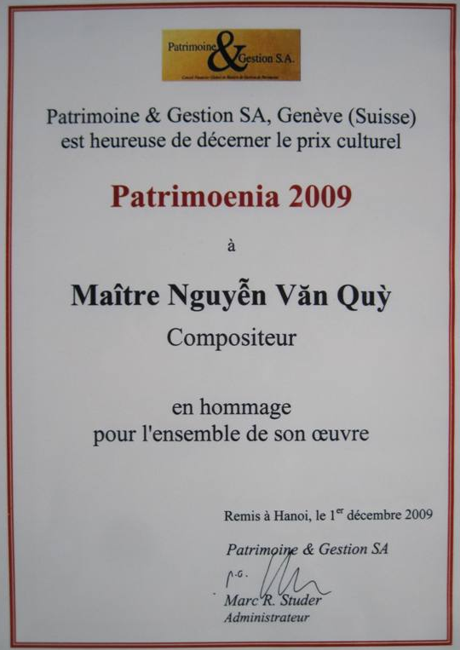

TABLE OF CONTENT
Introduction 4
1 Biography 7
1.1 Family and livelihoods 7
1.1.1 Hard livelihood 7
1.1.2 Three teachers 9
1.2 Teacher Nguyen Van Quy 12
1.3 His present life 14
1.4 Tour to France 18
2 Chapter 2: Influence and study 21
2.1 Music tradition from his father 21
2.2 Chorus at church 21
2.3 Harmony training through a correspondence course 22
3 Lifestyle and Personality 25
3.1 Lifestyle and Personality 25
3.2 Philosophical point of view 31
4 Composition and Works 36
4.1 Songs 36
4.2 Nine sonatas for violin and piano 37
4.2.1 Why I selected sonatas? 39
4.2.2 Features of his composition 42
4.2.3 Prizes 46
4.2.4 Performance in public 48
4.3 Poems 52
4.4 Feedback and appreciation 61
5 Conclusion 64
Special thanks 67

Introduction

The Embassy of Switzerland in Hanoi organized a special event on 1st December 2009 to congratulate musician Nguyen Van Quy and honour his works. The ceremony received a lot of respected guests, both foreigners and Vietnamese, including Chairman of Vietnam Musicians Association, Director of Vietnam National Academy of Music, General Secretary of Vietnam Historical Science Association, and local artists… During this music night, Patrimoine & Gestion SA, Genève – Suisse (a Heritage and Conservation organization based in Geneve – Switzerland) showed their honour to award the prize for Cultural Heritage Patrimoenia 2009 to Maître (master) Nguyen Van Quy.
Long before this event, his name had been well-known in the Vietnamese music circles. He is the only Vietnamese musician who completed 9 sonatas for piano and violin. All of these 9 sonatas are highly appreciated locally and internationally. In 1994 Nguyen Van Quy became the first Vietnamese- citizenship musician of Society of Authors, Composers and Publishers of Music (SACEM), provided that the performance of his works in Vietnam was not subject to SACEM royalties.
His foreign friends like Mr. Jean – Hubert Lebet - Swiss Embassador; Ms. Bertile Fournier – Professor of the central music school in Paris, Chairwoman of Lily Luskine Music Association, and chairwoman of various international music competitions; Mr. Paulette Kappweller – French musician; Ms. Isabelle Durin – No.1 violinist of the French national symphony orchestra; Dr. Tarique Farooqui – former Representative of UNICEF Vietnam; and a lot of French audience who were connoisseurs in academic music call him “Beethoven Vietnamien” (Vietnamese Bethoven). His local friends call him lovely Quy Sonata. “Nguyen Van Quy - Cultural Heritage Patrimoenia 2009” is composed to talk about the said prize and his life.
He is now 87 years old but he has been devoted to music since he was 5 years old. Music accompanies with his whole life, brings him a lot of misfortune and misery but, above all, it helps him find himself and happiness in life. Thanks to music he can find his audience, friends and achieve international prizes. His career is attributed to his great efforts, passion for music and rare talent as a German artist calls him Talent. The musician has spent most of his writing life on composing sonatas (this type of music is difficult to approach and still strange in the music life of Vietnamese people). Without his passion and courage he could not have climbed to the peak of Vietnamese sonata composition as he has. Nguyen Van Quy has composed 9 sonatas for violin and piano and these all have been locally and internationally recognized.
His works have been early included in SACEM, training curriculum of Vietnam National Academy of Music and music schools of some nations. Though the musician has got such great success he is so modest in daily life and shining in hearts of his friends, colleagues and fans.
Nguyen Van Quy - Cultural Heritage Patrimoenia 2009 is a booklet that introduces a music talent to readers from Vietnam and other countries. This is not simply a biography. Apart from introduction of his origin and path to music the booklet also expresses his thoughts and feelings. It is because, to date (2011), musician Nguyen Van Quy is still sound in mind to tell the happiness and sadness of his life and career. In addition, this booklet also presents his works and comments from prestigious artists, both locally and internationally, about his life and music. Readers of this booklet can understand to some extent musician, composer and teacher Nguyen Van Quy. To make a difference from a lot of other writing about artists and show the objectiveness “Nguyen Van Quy - Cultural Heritage Patrimoenia 2009” also quotes some special parts of television programs and articles produced about him.
The author of this booklet also presents a lot of documents provided by the musician during their discussions and talks at No.13, Nguyen Quang Bich street (Hoan Kiem district, Hanoi) as he still had good memory despite his age. He always told in detail and showed a lot of documents or papers as true evidence of his stories about his life with numerous happenings, his composition career, his friends, and organizations as well as individuals respecting him. His life is like a century-long historical documentary with a lot of misery, merriness and turning points.
This booklet was prepared with a true style of writing, did not exaggerate or praise from a personal point of view. It answered such questions as Which childhood marks shaped such a person of music? How is the musician’s life? Road to his sonatas? International and local evaluation of his works?... The readers should feel by themselves his influence, value of his works and their strength. Nguyen Van Quy - Cultural Heritage Patrimoenia 2009 is the greatest archive to keep image of a talented composer of Vietnam and the world. The booklet will be contributed to the cultural heritage conservation collection of Patrimoine and Gestion SA which awarded Patrimoenia 2009 prize to musician Nguyen Van Quy.

Hanoi, June 2011

Biography

Family and livelihoods
Nguyen Van Quy was born on 2nd January 1925 in Hanoi as the second child. His father was a post staff and good at performing monochord (đàn bầu). He frequently organized music performance at home. Therefore, Nguyen Van Quy absorbed folk music when he was very small.
Despite his passion for music like his father and his intelligence he got bad luck very early. His mother died when he was as young as 5 years old and his father passed away when he was just 13. He then had to live with his step mother and on heritance from his father. His family tragedy brought him spiritual suffering and difficulties but it also gave him a thirst and extraordinary energy.

Hard livelihood
His heritance supported him until he finished primary higher education (Enseignement primarie supérieur). He then fell into extreme difficulty, neither parents to take care nor money to live. Such context might possibly push people down to the bottom of the society and become malefactors and that way would lead to the hell. Hơever, the young boy Nguyen Van Quy did not go that way. “Can’t lose my personality and self-respect!” – he always said in mind that he had to struggle. He was determined to earn money to continue his study and pursue his passion for music that was also his deceased father’s wish. He earned life by teaching.
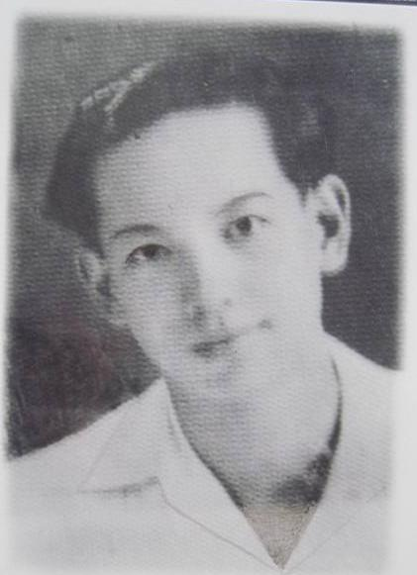
Nguyen Van Quy at 16

When he was 16 Japanese fascists attacked Hanoi and closed French schools. The young boy then started to earn money by teaching children of French families. As a result, he got money to stabilize his life and study for the first two years of secondary education (Enseignement secondarie) at Thang Long school.
When the war happened, Nguyen Van Quy paused his study to join anti-war performance together with a lot of other patriotic youth in Thanh Hoa province. Later he studied at Civil Engineering University in Yen Mo district, Ninh Binh province and then taught music at Resistance Arts of Region 3 in Luc Thuy (Hanh Thien village, Nam Dinh province1).
The page about his early life with difficulties was closed then and a new page was open and stick to his music career. It should be added that the difficult life gave birth to Nguyen Van Quy with proud energy for life.

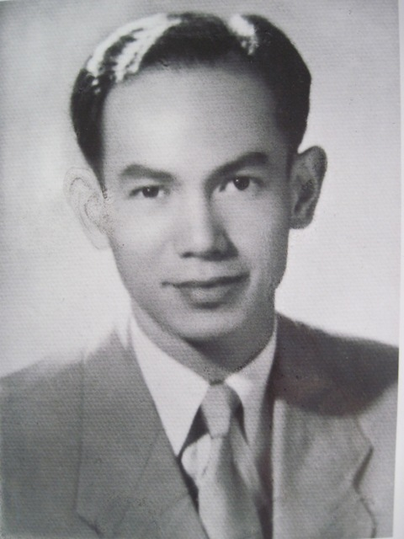
Young boy Nguyen Van Quy
He started composing

Three teachers
Talking about dificult years of his study he repeatedly mentioned three teachers who helped him struggle for life. He loves them and is grateful to them forever.
The first teacher is Hoang Minh Giam1, Director of Thang Long school where Nguyen Van Quy studied when he was 14 and 15 years old. The teacher saw the situation of his orphaned student and, therefore, gave him a full scholarship until he finished first two years of secondary education. The scholarship is high enough to create good condition for Nguyen Van Quy to study and make effort.
When the war was over Hoang Minh Giam was promoted to be Minister of Foreign Affairs. He once came to visit his student’s home and felt happy to see that Nguyen Van Quy started composing music.
During his study for first two years of secondary education diploma at Thang Long school, Nguyen Van Quy was also taught by a master in literature, Mr. Émile Caze, and he turned to love and write French prose and verse. His French language competence was enhanced and he started writing French poems.
Related to teacher Hoang Minh Giam, there is a story about the meeting between him and Nguyen Van Quy at Hanoi Grand Theatre. He, at the same time, saw General Vo Nguyen Giap and shouted loudly: “Giap, here is Quy!” At that time, he was Minister of Culture, a high position in the Vietnamese Government, but still had sincere love toward his student. This proves that despite high position and heavy responsibilities good-hearted people never forget their old acquaintances.
The second teacher mentioned by Nguyen Van Quy is Dang Phuc Thong1 who was Director of the Civil Engineering University (Yen Mo district, Ninh Binh province). Because Nguyen Van Quy entered the university 3 months later than his peers he lost the early lectures. Director Dang Phuc Thong spent his lunch time on delivering the missed lectures directly to Nguyen Van Quy. With the kind help from the teacher Nguyen Van Quy could supplement his knowledge and caught up with his friends quickly. He told that sometimes they taught and studied under moonlight and Nguyen Van Quy played guitar during breaks, the teacher loved his guitar music a lot.
His third teacher is engineer Ho Dac Lien2. He was a mineral engineer. After studying mining and geology in France he returned home and taught at Civil Engineering University. He loved Nguyen Van Quy a lot. He once talked with this student in French (as he could not speak Vietnamese when he went back to Vietnam together Uncle Ho) that “you can think in mind that you are happier than me. When you get sad you have your guitar, for me, I don’t have anything.”
Just some months after entering the university Nguyen Van Quy stopped study to teach music at Performance Sub-Association of Region 3. Hearing that news Director Dang Phuc Thong did not agree, but Mr.Ho Dac Lien said: “Let Quy go. He was born for his guitar, not related to public works”. Musician Nguyen Van Quy told that: after Hanoi was liberalized he once saw Ho Dac Lien getting out of a car he greeted the teacher, the teacher smiled and put a hand on his shoulder and asked in Vietnamese “My son, what do you do now? How’s your life? I’m happy whenever I hear your songs on the radio”; this hearty regard encouraged me to continue my music career.

Teacher Nguyen Van Quy
One of important jobs in his life was teaching. He became an official teacher of various schools in Hanoi in 1954. He made great contribution to training and shaping of music teacher evaluation standards at a lot of secondary schools in Hanoi. Teaching was not only a stable source of income but also helped him to train a lot of student generations by his love for his job and music.
After Genève Agreement was signed in 1954, Nguyen Van Quy lived in Hanoi and taught music at Chu Van An senior secondary school1 for 6 years. After that he moved to Hanoi Teaching College2 (between 1959 and 1978). It is Nguyen Van Quy teacher who made the first contribution to formulation of Music Teaching Department (now it is music major of Music-Painting-Gymnastics Department) at the college and helped it become the pioneer in music teacher training among colleges and universities in Hanoi.
As a teacher, Nguyen Van Quy thought that music played an important role and function at school. Music is not only an education content but also an integral medium of education. Through learning music students have another medium to get aware of the nature and society. Once students are aware of, understand and love the beauty they can make effort to create the beauty. Music makes an important role, directly and indirectly, to moral and mental education.
From the above point of view, Nguyen Van Quy taught with all his mind and strength. During nearly 30 years’ teaching, the teacher worked like a hard working builder, trained a number of pupil and student generations to build up their love for music. Many of his students have become well-known artists in Vietnam, some of them followed him to become teachers of music.
A lot of students now still talk about this teacher with respect: “His image with tall and thin stature, high forehead and bright eyes remains in my mind… We can’t forget his commitment during his harmony teaching and work analysis, or his patience during his proposal for our voice and beauty allowance, heavy work exemption. We can’t also forget his serious but dear advice. For us he is not only a musician but also a respected father” – Thanh Ha wrote in an article namely Teacher Quy “Sonata”/ Sunday Culture Journal No.1045 (between 19th and 22nd November 2004). Thanh Ha is one of the trainee teachers of the first music class of Hanoi Teaching College, trained by Nguyen Van Quy.
Nguyen Van Quy worked as teacher not only at school but also at his home. Since retirement, despite his old age, he has been continuing his teaching. It is to use his free time properly while his health allows and to express his passion and love for teaching in a relatively special way. Besides music composition, he is teaching French for some foreigners working in UNICEF, some of them have become his close friends. He is also a teacher of music instruments and music aesthetics for students at different ages. On special occasions his former students come to visit him. Many of them have been successful and are living overseas or domestically. They all still pay attention to, love and thank him.
His attachment to teaching, a sacred and noble profession, brings him a very beautiful and significant time during his life. He has written a successful and well-known song to praise this profession.

His present life
The musician is now living with his family at No.13, Nguyen Quang Bich street, Hoan Kiem district. His wife is Do Thi Nam Kim who used to teach French for doctors and pharmacists before they went abroad for work. They have two sons.
Unlike a lot of well-known musicians of Vietnam, Nguyen Van Quy has lived a quiet and simple life together with his family and friends since his retirement. Amid a busy ancient street of Hanoi he lives in an ancient house of French style, built in 1790s, less than 50m² large. Visiting his home we saw a living which was simple but very “Hanoi” with an old tea table, fresh flower vase and book shelf containing so many souvenirs and music works… His music corner is in the same living room, hung on the wall a large-size portrait of a famous composer - Ludwig Van Beethoven, and his old piano which accompanied with him for his sonatas (Sonata No.1 was completed in 1964, Sonata No.9 in 2003) highly appreciated by international and local experts. He stores carefully research books and documents in his wooden cabinet that has become too small after years. He has in the living room a rattan chair on which he sits and enjoys his sonatas from his old phonograph.
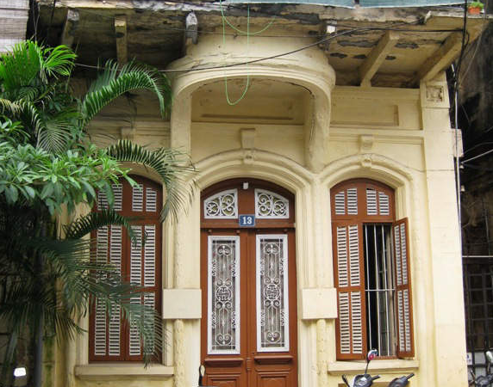
Musician Nguyen Van Quy is now living at No.13, Nguyen Quang Bich street, Hoan Kiem district, Hanoi.

With his great awards Nguyen Van Quy is getting well-known. His home is frequently visited by music fans. A lot of journalists and reporters have come here and produced articles as well as TV programs about his life, career and compositions. Local people not working in music field learn about him from such articles and programs. He is respectedly named: Beethoven of Vietnam, King of Vietnamese sonatas, Master Quy sonata, composer, teacher Nguyen Van Quy…
In contrast to the halos of his music career Nguyen Van Quy selects a quiet life together with his old wife, children, grandchildren and melody of this sonatas which always resound in his mind. He is living a modest life and satisfied with his present.
Hanoi where he was born, grew up and lived his whole life saw the growth of the music talent. With the love for his hometown he has contributed his intelligence and strength to decoration and conservation of the beauty of this capital with thousand years’ culture. At the age of nearly 90 he is living quietly as a witness of numerous changes, ups and downs on this land. With his sophistication he realized very early that Hanoi was like a sonata and the land is full of human feelings and manners, emotional levels, contradictions: happy and sad, exciting and quiet, concerned and calm, love and hate… That is Hanoi for composer Nguyen Van Quy, it is his all life, a wonderful sonata.
Recently, in 2000 when Hanoi celebrated 1000th anniversary of Thang Long capital foundation his name was included in the book honoring special people of Hanoi. The book entitled “36 Hanoians” tells about 36 characters as 36 perspectives toward those who are keeping the breath and values of Hanoi – the capital of Vietnam. They are live heritages, have been contributing to Thang Long culture. Many of them are living on simple jobs, not well-known and have no researches on Hanoi, and even have not been mentioned by mass media. They are simply an old teacher who is now working as a pedicab driver beside Hanoi Grand Theatre; an old book collector, a master artisan attached to the traditional bronze casting of Ngu Xa village, a woman producing rice noodle (pho) for decades… But it is them whose quiet work has been day by day making a contribution to preserve sources of heritages for Hanoi.
Besides the above persons a lot of others also have made contributions to shaping cultural values of Hanoi. They are well-known professors, doctors and artists. They have become successful with their careers. They have contributed to the fame of their capital and improved position of Hanoi on the international arena. Nguyen Van Quy is one of such people.
Nguyen Van Quy is a son of Hanoi. His life is attached to and he becomes successful in his career as a musician in parallel with the career as a teacher on this land. The gentle but very beautiful melodies in his compositions are deeply attached to the land. These compositions have partly contributed to the cultural values of Hanoi, proven by Patrimoenia 2009 prize which was given to him in a very special event.
It is an honor and pride that such noble prize is awarded to a talented musician of Vietnam. This prize also glorifies the capital as not all nations have citizens who are considered a heritage in the field of music for centuries.

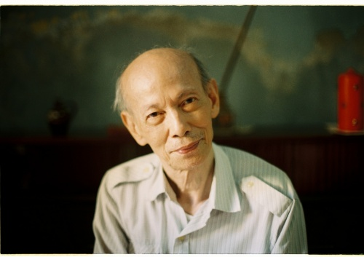
Musician Nguyen Van Quy’s photo in “36 Hanoians”
Not only his music but also he himself shows spirit and qunitenssence of Thang Long land. It is the elegance and deepness of an aged artist; the modesty in life of a retired teacher and a person with love for Hanoi.
As a well-known person in the field of music, Nguyen Van Quy is successfully portrayed in the above special book. Author Nguyen Thi Mong Diep wrote about him that “Music resounded in the ancient house in Hanoi and gradually got over in the space… It made me immersed in vague emotions which I could not name. I felt happiness, sadness, worriedness and belief in beautiful things… And I saw my old friend. Gentle. Lonely. Haughty and shiny.”1
The lovely words were written by Nguyen Thi Mong Diep after listening to his music. She smartly linked his appearance to his music. It is a special way to portray a character, making Nguyen Van Quy appear in the book with differences: “Gentle. Lonely. Haughty and Shiny”. The book was produced by VietPictures and published by Thế Giới Publishers in December 2010.
To commemorate 1000th anniversary of Thang Long – Hanoi, the book “1,000 Thang Long-Hanoi songs” introduced his works. This is a huge music publication full of Hanoi spirit. A Hanoi with very particular beauty is regenerated by music with its seasons, streets and people. The book was compiled by music critic Nguyen Thuy Kha. It is a collection of songs about Hanoi at different phases, written by more than 500 Vietnamese writers. Nguyen Van Quy’s songs included in the book praise the heroic capital during the war, these songs are closely connected to his name. However, it is a pity that words and music of some songs were modified, especially Chiều cô thôn (Lonely Village in the afternoon).

Tour to France
With France, Nguyen Van Quy seems to have a legendary bond.
When he was at Thang Long school for the first two years of secondary education he was excellent at French, both speaking and writing skills. He also wrote sweet and romantic poems in French. Some French writers and poets with famous writing inspired his soul and feeling. Greedy for knowledge the young boy not only read, studied but also understood thoroughly their writing. He even learned by heart long poems. The aesthetic beauty and romance of French literature got into him since then.
Nguyen Van Quy then started to learn about France and study deeply the beauty of French music. He began a higher training on harmony at Open Paris College through a correspondence course with the teachers he had not met before but these teachers highly appreciated the assignments prepared by a student from a far away country. During his journeys to France later Nguyen Van Quy looked for these teachers but he could not contact them as some of them had passed away.
At the moment most of his foreign friends are French. Some of them are music artists and have directly invited him to France in order to contact directly with a Vietnamese talented musician; and they were surprised at and loved his music. Some of the friends were his students. Some are friends who he have not met but they enjoy his music and send him sincere letters …
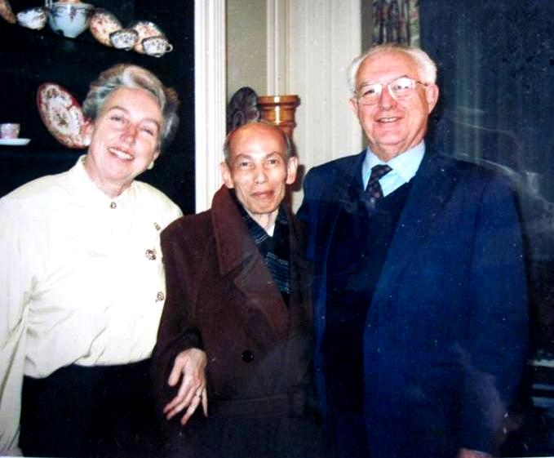
Nguyen Van Quy and Ms. Bertile Fournier and her husband during his visit to Paris

In 1993 Nguyen van Quy was invited by Ms. Bertile Fournier (professor of central music school in Paris, Chairwoman of Lily Laskine Music1 and Chairwoman of various international music competitions in Europe) to France in order to introduce his sonatas and scores. In 1994 and 1996 he was also invited to France to work and provide score of Sonata No.6.
During his visits to this West European nation Nguyen Van Quy came to see its proud symbols such as magnificent Eiffel Tower, romantic Seine river and ancient Notre-Dame Cathedral… In such impressive space musician Nguyen Van Quy had different emotional levels. “French people are famous for romance, even their language and music with strange melodiousness and mildness”- Nguyen Van Quy remarked. Leaving France he brought home memorable memories, not only about the landscape and people but also about the profound feelings he received from his friends. He also left some sonatas and music arrangements at the French National Academy of Music.
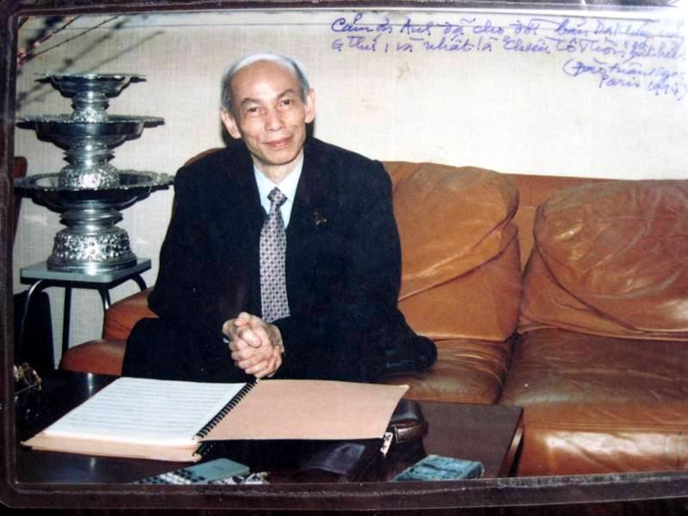
Musician Nguyen Van Quy in Paris
Photo taken by artist Doan Tuan Ngoc during his visit to France in 1994 – with writing “Thank you for your composition of “Serenade” of minor G and, especially, immortal “Rural girl in the afternoon”
It is special that his last sonata, Sonata No.9, was composed in 2003 for a woman artist Isabella Durin, the No.1 violinist of the national symphony orchestra Ile de France. She went to Vietnam twice in 2004 and 2006 to perform Sonata No.7 and Sonata No.9 of Nguyen Van Quy.

Chapter 2: Influence and study

Music tradition from his father
Nguyen Van Quy’s father was a Government official. He loved folk music and could play monochord well. His old house in Phu Doan street in early 1830s was the place his father usually gathered his friends to play folk songs such as Hành vân, Lưu thủy, Cổ bản, Kim tiền, Tứ đại cảnh… Since Nguyen Van Quy was 5 years old he lived in the special music world of folk music. Under the guidance of his father was taught basic musical theory and sight singing at primary school. When he was 12 years old he learned guitar, could play bango and started to learn basic harmony.
His father’s special guidance generated foundation for his music capacity development later. It can be said that it is his father who shaped Nguyen Van Quy’s passion for music first and made a contribution to deep music aethetics of this talented musician.

Chorus at church
Nguyen Van Quy’s childhood was a mixture between quinessential folk music of Vietnam and academic music of Austrian and German master musicians. When he was 12 years old his father let him to go to Ecole Puginier school, a denominational school. At this school he was selected to the children chorus to have weekly performance of classical works by well-known musicians like Bach, Hanedel, Mozart, Haydn, Beethoven… at Hanoi Church.
Being impregnated with two music currents since he was small his compositions later were considered the clever combination of the quintessence between Vietnamese traditional music and Western academic music. He has created a totally new language, different from the music of other times. A lot of musicians have recognized it the most wonderful combination!

Harmony training through a correspondence course
Nguyen Van Quy was 21 years old when the Government took over the capital. He then joined Luong Ngoc Trac’s musical band including such artists as Lê Yên, Lê Lôi, Phạm Đăng Hinh and Hoàng Thái. This band also went to China to play for Con Minh tea-room. It is the first music band of Vietnam to go abroad. After that he played for New Artist tea-room – Hanoi together with Nguyen Xuân Khoát, Phạm Van Chừng, Mai Khanh and Thương Huyền.
During the war, when the country was in difficult situation and all individuals had to be responsible for the fate of the country and showed their patriotism in different ways, Nguyen Van Quy paused his study and actively participated in anti-war performance. He and his friends, young people of Hanoi, contributed their music and singing to the nation. He was ardent to join anti-war performance in Zone 3 and Zone 4 which were very important during the war. A lot of people still remember that young boy bring a guitar with radiant smile as he found the love for life and nation from music and revolutionary waves of the time.
Being sent back to Hanoi by the French expeditionary force, Nguyen Van Quy continued his music study. In 1953 and 1954 he studied harmony through a correspondence course of Open Paris Colleage.
During such time he continued his teaching job to earn money for his study and daily life. To save money for stamps, instead of sending 2 or 3 assignments once, he sent even 6 assignments in one envelop. His assignments were highly appreciated by his teachers, even got score 20/20. Professor Adolphe Borchard, his teacher, said “Your assignments are very good. If you continue to study like now you will get very good achievements”. As he is intelligent and hard working he quickly impressed his teachers. However, the young boy understood that he had to perfect himself. Besides following training curriculum he started to handwrite harmony works of scholarly composers like Paule Maurice, Pierre Lantier, Gabriel Garbé…
He is still keeping carefully the textbooks used during the above course. He has studied these so much that they have become very old. They contain his hard work, a lot of finished harmony exercises and marks given by his teachers for his assignments. Beyond the difficult life, with his energy, intelligence and diligence Nguyen Van Quy could finish the training course within 16 months only.
As a result of the course, Nguyen Van Quy has achieved useful knowledge of musical theory, he could compose music methodically and skillfully. That is the luggage he provided by himself and it helped him greatly in his composition later. From this course his talent as a music teacher and musician was quickly shaped.
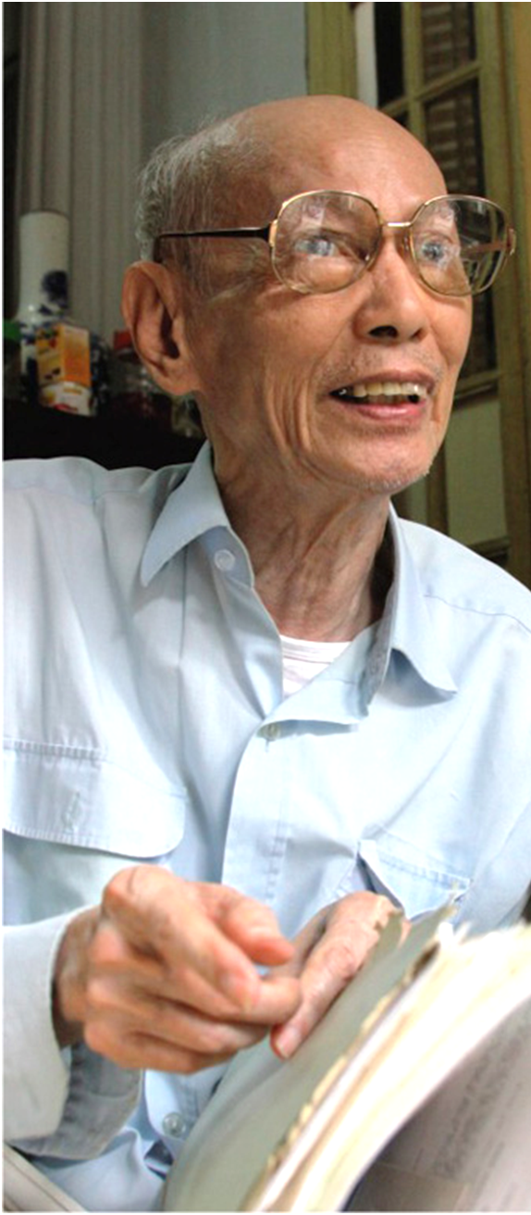
I LOVE MUSIC!
- Nguyen Van Quy -

Lifestyle and Personality

Lifestyle and Personality
To be honest, it is not easy to describe his personality. When contacting with him we feel both a gentle man from his figure and soft voice but also a man with serious thinking, willingness to have peremptory criticism against deviatory, tricky and ungrateful lifestyle. He selects for himself a simple and quiet lifestyle but from himself other people still see bright and sparkling light of a great artist. He is really attractive and admiring. He is there but vague and difficult to understand.

It can be asserted that Nguyen Van Quy has special personality and lifestyle. He cannot be mixed in a crowd!
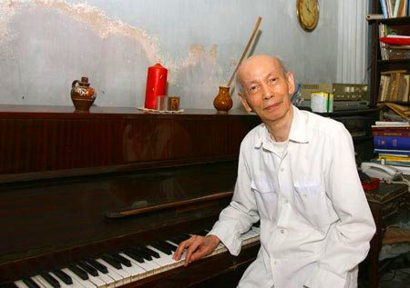
Musician Nguyen Van Quy by a piano

In daily life Nguyen Van Quy seems to be a fish out of water. He is out of tone even in his family. For a long time he was not supported by his family. In his composition career he is the first and only musician in Vietnam who has composed 9 sonatas for violin and piano. He has taught and trained a lot of students but none of them followed his hard way. To date, he is still a lonely walker on his road of music.
Although he is honored by French as Beethoven of Vietnam, King of sonatas, and well-known he selects a simple and quiet life in an ancient house for his old age. Not noisy and high-faluting at all. Nguyen Van Quy does not care the ambition and hustle of the daily life full of changes. Music and his friends, his students and those who love him are his source of happiness in his life.
About a decade ago when his health was good enough people used to see an old musician at a piano playing gentle and profound music of his sonatas. Such echoing sound and image were so special in the busy old quarter of Hanoi and went into a lot of documentaries on TV. In some recent years his hands became shaky and he could not play music and continue his composition. Every day people in the same street see in his house No.13 a small old man sit on the rattan chair showing a pensive expression or enjoying his compositions from the phonograph. Sometimes they see him talk with his friends about never-ending stories of life and music. His simple life is so natural but shows a noble personality and it is also the specialty of his character.

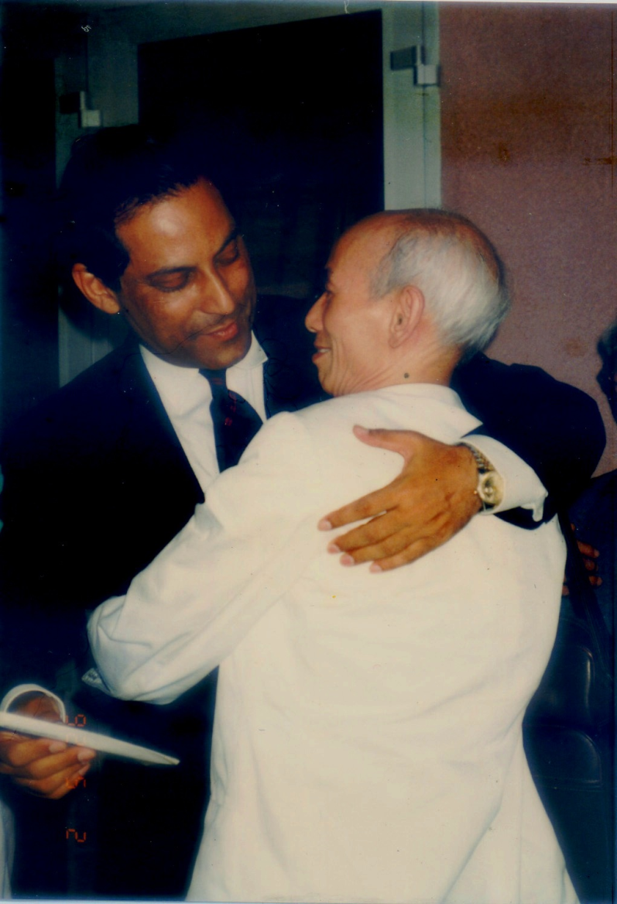
Composer Nguyen Van Quy and Dr. Tarique Farooqui, UNICEF Representative in Vietnam

His point of view on human life is linked to the great thought of pure spirit and wisdom. He pursues this thought not only in his life but also his teaching and composition. He thinks that “Without beautiful and pure feelings you can’t master the intelligence and help yourself as well as your community”. This was expressed in 3 themes of 3 movements in his sonata No.5: feeling, purity, intelligence. After hearing the musician talking about this thought Dr. Tarique Farooqui shook his hand and said that: “I totally agree with your philosophy of life; and I wish to come more to meet a person I respect not only for talent but also great thought”.
With that point of view, Nguyen Van Quy can always control himself in his action and thinking. He usually keeps silent when he sees rude and uncultured behaviors. He has experienced difficult life, seen good and bad people in the society of different times. With his rare music talent he suffered a lot of contempt, blocking and envy but he did not resist, complain or deeply resent at all. After having general evaluation of his works a lot of artists agreed that there should be a more deserving position for his works in the Vietnam’s history of music and more favors for this talent. However, so far, Vietnam’s music has not given him an appropriate position. Maybe it has not realized such great talent?
Nguyen Van Quy always keeps a balance in his inner feelings, not grievous at all. “Good wine needs no bush” is true for his dignity. After discussing with the composer, even though he did not speak out, a lot of journalists felt his inner feelings and thinking. His music has not been aired on TV for years and performed for the public but, certainly its noble value is still recognized by the world and will stay there forever.
About his life style, starting from the poor and hard background he was familiar with insufficiency. He was not afraid of difficulties. He did not become a servant of money but wished to earn money to master it, to serve art activities and share with those who are in difficulty also. For example, after receiving a lot of money from the Cultural Heritage Prize 2009, he donated all for poor and disabled children in Hanoi and Ho Chi Minh city. He always thinks it an ordinary action. It simply stems from himself, a good deep of a pure soul that is full of love.
About himself, he always has good sentiment, pure soul, soft voice and gentle manner. His gentleness can be seen not only from himself but also from his works. For composition, he prefers beautiful and deep motifs; and gentle melodies. For sonatas he selected only violin and piano as he thought that piano could express the purity of the intelligence while violin could express deeply different states of the soul, especially eagerness and tenderness. Both of them have good inspiration and are special. Brass, drum or gong is too noisy, shrill and nerve-racking. They make audience started, insecure and unsatisfied… He never uses those instruments.
Nguyen Van Quy appreciates sad music. He thinks that with sad music people can love. He once wrote in an article that sad compositions brought consolation for the people in sorrow, changed sorrow to strength or gave mildness and comfort for the people in stress. In composing sad music it is necessary that the composers must avoid expressing sorrow in a stalemate and depressing way. Sad music can build up people’s soul and sentiment. If we were sad on the face of someone’s pain, we would pity him, and even sometimes feel angry at what caused this suffering.”

Sad music makes up most of his works, including vocal music and instrumental music. Among his songs, Serenade was born in the hiccup and cry choked with emotion for the death of his young friend. A lot of other songs have sad images of sunset, night and loneliness: Chiều cô thôn (Lonely Villge in the afternoon), Bóng chiều (Sunset), Cánh chim chiều (Oar in the evening)... In his sonatas, their second movements are usually slow and deep. However, it is special that despite such sadness their works never become mournful or reach an impasse.
Although his music is sad it does not make the audience feeble. Instead, it urges the audience to make efforts to overcome their fate. Listening to his sonatas and feeling the freedom from his compositions the audience will have magic and romantic emotion. It seems that hard life with daily worries no longer exists, miserable and disappointed people are no longer seen, only a fanciful and sparkling world exists. When the audience feel that he will certainly see totally different melodies.
Nguyen Van Quy respects truth. He is satisfied with himself when he speaks truly: “I think that if I have honesty in my works it will some time certainly touch the audience’s heart. Without truthfulness and honesty you can’t reach aesthetics…”. Music reflects the state of his soul. Those who work for art must make great effort for aesthetics. His works are very beautiful. It means that they have reached high-level aesthetics. Their sound has pure beauty and, of course, also the Truthfulness and Honestly. Truthfulness is always appreciated in his compositions. His talks with his friends and colleagues are usually accompanied with specific evidence. He is never self-deluding or self-boasting. He ignores defraudation and falsehood. For him, in art or any other sectors people cannot get success if they do not start from their truthfulness, or even if they can their success will collapse soon. Despite his embarkment in music and composition of sonatas in the difficult situation of the subsidized economy he never loses his heart.
Gentle and reasonable – this remark is true not only for himself but also his works. He has been working diligently for more than 40 years to compose music for different instruments. Talking with others is an occasion for this musician to reminisce about his old memories. During his talks about his life the audience will see his logical and coherent thinking, much different from his age of 87. Under his high forehead his eyes become brighter when someone talks with him about variation, musical theory, creativeness and uniqueness in music.
As mentioned above, Nguyen Van Quy has special characters. He is a gentle man but his argument is so strict and incisive that others can hardly criticize. This is shown not only in a teacher’s music argument but also in his articles on some main newspapers of Vietnam (Nhân dân, Tạp chí cộng sản). His articles are mainly editorials and critiques about the role of music in life and education, or argument articles about improving the music appreciation capacity of the public. For such articles he used true language even though they mentioned theory he always expressed it clearly, logistically and easily. With his loud and self-confident voice and his saying always is very persuasive.

Philosophical point of view
His philosophical point of view is also interesting. For years he has studied philosophy passionately, not to become a specialist or philosopher but to meet his own needs. This is partly linked to his personality, life point of view and usually suitable for those who want to learn difficulty and misery. Nguyen Van Quy is a man of specialties!
He is not only a musician, a poet but also a man who likes deep thinking about philosophy, few people know about this. A lot of other musicians do not kill time for such thing.
Nguyen Van Quy does not go too deep into individual points of view and influence of a philosopher. He studies philosophy and thinks of it in a special way to answer his own questions or simply to explain his surroundings. He spends much energy on considering nature of every matter, frequently reads books about well-known philosophers like Platon, Leibniz, Kant…to learn more. It goes beyond the simple thinking of an ordinary person in daily life. Maybe those who are not much taken care of usually find strange things for themselves in the life to fill the voids in their soul explore and enlighten themselves.
Nguyen Van Quy does not link philosophical points of view to his daily life but also his thinking and composition. Therefore, the audience must listen to his compositions many times to understand them. “Right music” is the music that serves the nation and laborers; improves people’s soul and awareness, enhances their love for the nation, people and life; excites them to work and build the society. Musician Nguyen Thuy Kha remarked that “As a witness, with his writing he told from the bottom of his heart the torment of a time, of the nation and mankind. And, therefore, it spreads forever in the human life”.
His works sometimes prove and confirm more the well-known philosophers’ ideas and points of view. He said “my creation helps me understand more Leibniz’s idea in proving: the beauty is naturally harmonized, exists in the inherently logical sensitiveness. When Kant analyzed this theoretical point he highlighted perception capacity of the feeling, not of the reason.”
Nguyen Van Quy admires Beethoven’s saying that “Music is philosophy of philosophy” and this is shown in the structure of all the sonatas he composed. He sees Beethoven as a genius musician who was typical for classical music and opened a time of romantic music. It has been proved by practice that classical music is a philosophy of life, a thinking channel for creation, very near the perfection of Truthfulness – Compassion – Aesthetics, and educative for human soul.
Nguyen Van Quy always pays attention to aesthetics philosophy in music. In his composition he applies not only musical principles, the combination of folk music and classical music but also his own aesthetical views.
He always believes that music can build up the soul, improve the spirit to reach a world of the most beautiful things. He himself considers Truthfulness – Honesty – Aesthetics as standards to evaluate, and mirrors to enlighten the values of the works. As a general definition, Truthfulness means to be true, right, contrary to the incorrectness and affectedness. Truthfulness in his composition means that his works are truthful, reflect the nature and universal truth of life. Honesty in his music is seen in its inclination to the good, his music brings audience to bright and beautiful feelings. It is like a soul filter for its audience. Even his sad music is never at a standstill but has the light of efforts for life betterment. Aesthetics means the beauty and all agree that art works must be beautiful. His works are also beautiful. Listening to his music a lot of listeners were moved and remarked about his beautiful and deep motifs. Maybe as Truthfulness – Honesty – Aesthetics is a great content of his works his friends said to him that Quy’s music touches listeners.
In teaching, teacher Nguyen Van Quy thinks that through learning music students have another medium to perceive the nature and society. Students cannot make effort to create beauty unless they are aware of, understand and love the beauty. He always orients his students to Truthfulness – Honesty – Aesthetics in life. Human is different from other animals in their efforts for beautiful things. Music is an activity for human, and, therefore, it has a wish for better life.
Even his songs also have highly philosophical significance. For example, a lot of Vietnamese teachers of different times were deeply imprinted as his famous statement “love profession as much as people” is included in a song “love profession as much as people” that is applied by a lot of artists, singers and teachers. That saying is like a precept of moral value in all times.

Love profession as much as people
Love profession as much as people.
Happy life, happy with new books, follow good examples in the history.
Love profession as much as people. Life is happy with singing, like a flock of bird singing, tractors working in our green rice field, near our school, we all together build the nation.

Let’s go, as people’s teachers we take care of young people day and night.
Overcome obstacles to devote to the nation.
Let’s go, as people’s teachers, our soul is so beautiful!.
The singing echos in the wind, our believe in tommorrow lights in our heart.1
That is the singing from the heart of a musician and also a teacher who was attached to teaching profession for more than 30 years. So far, this song is frequently used by the education sector of Vietnam, familiar to generations of teachers for decades and will be certainly hot.

Sonata for me is like a beautiful girl without makeup, we can’t realize that beauty at a glance, but if we pause for a while and look at it we’ll get amazed!

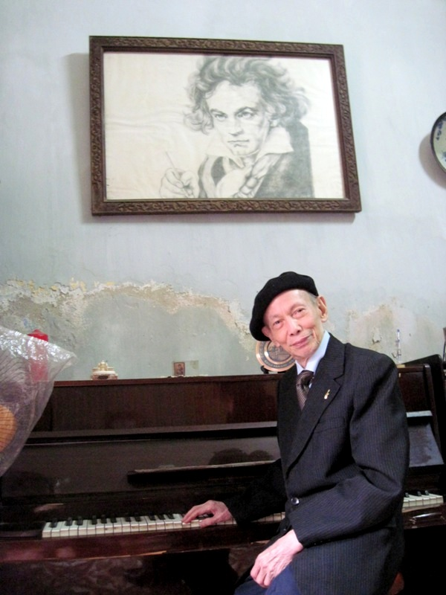
Musician Nguyen Van Quy by his piano and L.V Beethoven portray
- photo taken in April 2011

Composition and Works

Nguyen Van Quy’s music career is a composition process, a pathway from a young boy with love for music to an internationally well-known musician. Before becoming a composer he once wrote chorus, serenade and some songs loved by a lot of listerners (Dạ khúc, Bóng chiều, Chiều cô thôn, Nhớ trăng huyền xưa, Yêu người bao nhiêu ta càng yêu nghề bấy nhiêu…). But one day, he realized that he himself could not pursue such concrete thinking and had better return to abstract thinking as “it expresses myself more truthfully”. From this requirement he found that he was more suitable with clasical music, academic music for instruments and sonatas for violin and piano. Then he started to compose this type of music when he was more than 30 years old even though he admitted that sonata composition is the only pathway full of difficulties.
Nguyen Van Quy’s property is musical works, including songs, 9 sonatas for violin and piano, and poems in French and Vietnamese.

Songs
Nguyen Van Quy has a lot of songs of vocal music. He is famous with such songs as Mây trôi, Dạ khúc, Đôi bờ, Bóng chiều, Chiều cô thôn, Nhớ trăng huyền xưa… Their content is so diversified: love songs in praise of beautiful and unalloyed love of couples; songs in praise of Vietnam’s victories in the national protection and construction; and songs for children. Those songs were much aired on radio, sung by famous singers of Vietnamese new music at that time (Kim Tước, Mai Hương, Hà Thanh, Lệ Thu...) and supported by well-known music bands.
That radio program was highly appreciated and requested for many years in Vietnam. Listeners waited to listen to art songs for which the singers, harmony and introduction were all polished and significant. Nguyen Van Quy and his works made contribution to generate the profound significance for the whole program. With the music language full of romance, wafting classical fragrance, strength and joy he brought the audience relaxation and relieved their stress in life.
During the war, Nguyen Van Quy composed a range of songs: Hoan hô quân đội giải phóng thủ đô, Hà Nội giải phóng, Bác Hồ vầng dương của ta, Ngọn triều lên... to praise the national victory. They were disseminated on revolunary newspapers at that time. After Hanoi was liberalized, Nguyen Van Quy wrote songs to support the socialism construction and national reunion: Thanh niên trên công trường, Thủ đô làm theo lời bác. He also had songs for children: Yêu cờ Việt Nam, Dưới bầu trời xanh xanh…Among them “Love profession as much as people” is well-known in education sector of Vietnam.

Nine sonatas for violin and piano
In his music career the most valuable property is the 9 sonatas for violin and piano, composed between 1963 and 2003. He stopped at number 9 and thought it a full satisfaction and perfection, and he did not expect more. It is partly because of his health.

- Sonata No.1 was completed in 1964
- Sonata No.2 was completed in 1976
- Sonata No.3 was completed in 1979
- Sonata No.4 was completed in 1982
- Sonata No.5 was completed in 1984
- Sonata No.6 was completed in 1985
- Sonata No.7 was completed in 1998
- Sonata No.8 was completed in 2000
- Sonata No.9 was completed in 2003

There are a lot of special memories around these 9 sonatas:
Sonata No.1 is related to his journey to Sapa1 in 1963. During his journey he heard a song of the Meo ethnic group. It has strangely pure and popular sound. Coming home he was still obsessed by such sound and started to compose the first sonata with the spirit of that song. Sonata No.1 had special motif and was soon loved by performers and included in the music curriculum of the national academy of music. Since then he was officially known as a composer of Vietnam.
Sonata No.7 and Sonata No.8 are considered the twin as he had ideas about it and quickly recorded them for Sonata No.8 while he was writing Sonata No.7. He then had to pause Sonata No.8 to continue Sonata No.7. However, Sonata No.8 is the most successful work among the nine sonatas for violin and piano. It is assessed to be a romantic and attractive.
Sonata No.9 was composed in 2003 for Isabella Durin, the No.1 violinist of the national symphony orchestra Ile de France. This last sonata is assessed to be innocent, totally different from sadness of his earlier sonatas.

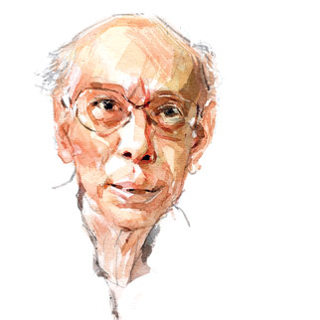
Nguyen Van Quy portray when he was 86 years old, by painter Hoang Tuong

Why I selected sonatas?
Nguyen Van Quy became musician when he was young and quickly got success with a lot of songs. He was well-known among his colleagues and the public. Musicians and artists highly appreciated his songs. It seemed that his music career would be shaped by song composition like a lot of musicians at the time. But it became totally different!
Nguyen Van Quy did not keep going on that flat road but turn to a new road: to become a musician for instruments, a composer who had sanatas for violin and piano. This is a special turning point for his career.
Despite his success in composing songs he, one day, realized that he had not better follow that pathway, it was not his expectation and himself. He then turned to wordless music which was considered to be too abstract, not provided by nature for both composers and listeners. Singing words, rhythm and dancing music are easy for both composers and the public. He did not negate their value…but, for him, academic classical music was his soul: “Sonata can help us go deep into instinct and abstract thinking, despite the intervention of reason. It helps me see the soul of my own and others. The audience may not see our feeling in life but they can see it from abstract settings of music”.
In spite of selecting the music with a lot of differences he did not want to be a gifted musician. He gave his whole mind to art methods. Especially, he had in-depth study on musician Beethoven1. He learned by himself from theoretical books of French, German music… He could write down by hand pieces of music from well-known works to learn the deep significance in composing music for different instruments. His passion got bigger and bigger day by day and made him decide to pursue.
Vietnam has a famous photo taken in 1960 of President Ho Chi Minh leading a symphony orchestra. It proved early attention of the President, the Party and State to this academic music. Wordless music will be an effective cultural bridge for Vietnam to integrate deeply and widely with the world. However, for a long time, that type of music was still quiet, not developed in the social life of Vietnam. The emergence of composer Nguyen Van Quy brought a new light, a torch to enlighten the search of true value for instrumental music in Vietnam.
For Nguyen Van Quy, although wordless music is not expressed concretely with efficient support of words it expresses deeply the feelings: happiness, sadness, worriedness. Sonata is the music for instruments, requires to express human being in the most truthful way. This type of music is like a “filter” for people’s soul in the busy society. He asserted that “only sonata – the music with high generality can express issues of emotional life and thoughts in the most profound way …”
Sonatas are tones of my life! His statement is the inmost feelings of a man who have experienced misery in life, the early death of his parents, his elder brother and second son… With piano he kept his own sadness to play life music.
It is special in his composition that all of his sonatas were composed for piano and violin but he has not used violin for many years. The music for violin is his imagination. He said “Violin is the King of musical instruments, not only because it is the deepest and its sound is the highest but also because it expresses people’s inner feelings and thoughts in the most profound way. When I sat down to write sonatas I sat at piano only, all of other things were imagined, especially the abstract world of violin techniques. I closed my eyes and drifted with my inspiration”. For piano with its black and white frets was the place where he released his soul to compose deep, daring and cheerful music.
Even though he think much and for long of all issues in life after thinking that something is worth speaking in music language he writes quickly. For example, just after he gave Movement 1 to violinist Nguyen Dinh Quy and pianist Hoang My he started to write Movement 2. And while the performers did not finish practising Movement 2 yet he completed Movement 3 already.
The musician put it “once I have strong emotion for composing nothing can prevent me. I do not accept any barriers from anywhere”. Therefore, he likes a story about philosopher Diogene. The King passed by when Diogene was sitting in a wooden barrel for sunbath. He asked Diogene “Is there anything I shall give you?” Diogene immediately answered “Please go out of my sunlight”.
Another small story connected with his compositions: sometimes a melody appeared in his mind but it would disappear if he did not record it. Once an interesting melody came up to his mind when he was on the way to the school, he thought that he could use it as a theme for a work, but after he arrived at the school and a colleague greeted him he forgot that. He felt so regretful then.

Features of his composition
After contacting his music a lot of artists, musicians and researchers remarked that his music was totally different, a new music horizon… It is unique style of Nguyen Van Quy.
His sonata usually has 3 movements:
Movement 1 or also called sonata movement. This movement may or may not have an introduction. The first part usually has two motifs that are called 2 themes with different tonalities and they are connected by a bridge. The bridge is frequently composed of some short riffs which have up and down tones – short and long rhythms. The bridge is used to strengthen the first theme and give notice for the second theme. The riffs of the bridges have unusual key signatures: sharp, flat…which are used to change from tonality of the first theme to the second theme. The second part of this sonata movement is to develop the themes. The third part is the last part of this movement, repeats the first part but the difference is that the tonality of the first and second themes are the same. In Movement 1, Nguyen Van Quy always follows the same content that the two themes must express two contrary aspects of a matter, e.g. unhappiness and happiness, excitement and peacefulness, firmness and softness, melodiousness… Despite the contradiction they have the same style and the same material to be treated to create the contradiction as 2 aspects of a matter.
Movement 2 are frequently slow and lyrical to attract the listeners. In most of his sonatas, movement 2 has poetic melodies, wonderful sound harmony and form perfection in music. After performing some of his sonatas, Professor Ngo Van Thanh, Director of the National Academy of Music remarked: “in his composition, musician Quy has created special movements 2 with melodious, deep and lyrical music”. A lot of listeners and performing artists call the musician “the man of the second movement”.
Movement 3 is the last movement of a sonata. It is usually quick, bright. It seems that music in the last part looks back once more and then concludes. Rondo movement is quick, the same tonality as the sonata movement, and used to finish the piece of music that has theme A between other themes in the order A.B.A.C.A. If the last movement is not a rondo movement it must have the same tonality as the sonata movement and be quick.
In general, in his all works Nguyen Van Quy did not want to use 5 or 8 consecutive notes of up and down tonality to create background music for various instruments, or to fill the work. In other words, during his composition he did not fill up his works with remplissage. Before him a lot of musician applied this way and sometimes remplissage diminished the value of their works. For him he thinks that when an instrument expresses the main idea the other instrument can express its own feelings and their tune will be freely contrary. If so, it sounds that the two instruments are in dialogue: if the violin is lamenting the piano will console, sometimes both seem to be discussing; if the piano does not think the violin will remind as if it invited the piano to come back to the real life. Then both piano and violin seem to be revitalized to talk and promote the composition.
Musician Nguyen Van Quy does not like Menuet with royal dancing or Scherzo with amusement. Especially, in the slow movements - Movements 2, he frequently created deep and sad feeling in the light of Schubert: “Is interesting music not sad?” He sought the beauty, the sublimeness but when he came back to the harsh reality he did not feel something missing.
In his compositions the musician did not want to write variations as he thought that when the composer developed a motif it means that he might have used variations, so it was not necessary to have a separate variation movement. Especially, he used unusual key signatures out of tonality, every measure has consecutive key signatures to express the meaning. This is clearly presented in Sonata No.5.
Like in his composition Nguyen Van Quy always has strict requirements for himself in his composition: keep creating new things, not repeat factors of old sonatas in the new ones. From the philosophical point of view, maybe he wants to follow a philosophical statement: no one swims twice in the same river.
For the content of a sonata, Nguyen Van Quy frequently gave the 3 movements the following content:
- Movement 1 mentions issues of life or his inmost feelings. This introduces the main theme and subordinate theme for the whole content of the work.
- Movement 2 goes further into his inner feelings or the issues mentioned in Movement 1.
- Movement 3 concludes, presents solutions to his inmost feelings or his wish for a change in life to reach happiness and make the life more beautiful. Sometimes it is an encouragement or urge.
With the same content but each sonata has different motifs. In Sonata No.1 in minor G is composed of 3 movements. Movement 1 is like Light with quick tempo, Movement 2 is like Love with slow and lyrical tempo, and Movement 3 is like Happiness with quick tempo and reappearance. In Sonata No.3 and Sonata No.5 the motif seems to revolt against the real life with a lot of sorrow. But in Sonata No.9 the musician accepts the life with two aspects: Happiness and Unhappiness…
In addition, a typical feature recognized by a lot of artists about his works is the combination between folk music and Western academic music. In Vietnam not all musicians want to compose sonata music and not all composers involved are successful in this type of music. However, Nguyen Van Quy has not only composed sonatas but also created great value for such music. For his works no folk instruments are applied but they possess something very Vietnamese. They are not also shaped according to classical, romantic or impressive school but it is full of Western musical spirit with unique beauty. This talented combination has created the specialty – new music surprises the audience and performers. Artist Ngo Van Thanh said “strict and a bit fantastic, classical but also daring, pleasing to the ear but difficult to play.”
In his composition, Nguyen Van Quy inherited quite clearly the principles of classical sonata form, he applied them creatively, mainly exploited figure, not focused too much on rhythm. Listening to his music the audience can feel deeply the music which has both lyrical philosophy and imposing images, but also a lot of concern about the human fate of the time.
His musical themes have been carefully selected so that they are expressive and able to treat materials. From an initial theme, in many cases, he has created a lot of new figures to enrich his music language. His theme treatment methods frequently used are syncope, opposite direction note, duration extension… The principled breaking of classical sonata form allowed him to reach various thinking corners, close to the soul of Vietnamese people. His works are assessed to be magically attractive. Foreigners who came to Vietnam for the first time and contacted with the Vietnamese sonatas did not feel strange at all. The Vietnamese audience felt familiar and moved. His music has not only the sadness about human fate but also the high-falutin, peacefulness and hope for a bright future.
The success shows that the road he selected is right. It brings fresh taste for the music life of Vietnam. And Nguyen Van Quy has found himself from the sonatas.

Prizes
When he was 30 Nguyen Van Quy got harmony degree of Open Paris College. His nine sonatas, finished between 1964 and 2003, are his biggest property that makes him well-known in the world and Vietnamese music. These nine sonatas also gave him a lot of noble prizes.

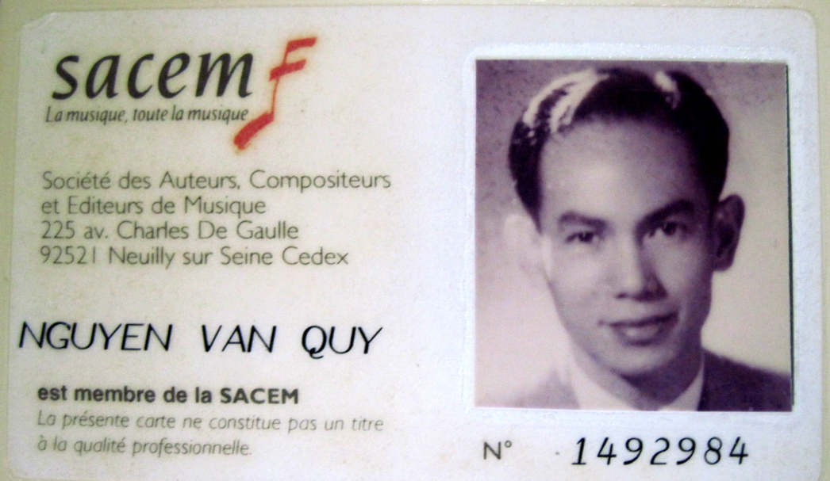
SACEM Membership card

In 1994 Nguyen Van Quy was the first Vietnamese person to participate in SACEM. The Decision was signed on 14th June 1994. Especially, Nguyen Van Quy was not subject to any examination to become the membership. The regulation of SACEM “The Board of Directors has the power to exempt from examination those composers whose reputation and professional abilities appear to it to justify this exemption”.
In addition, in his agreement with SACEM he had a condition that the performance of his works in Vietnam was not subject to SCAEM royalty payment. He explained simply that “I don’t want my works to be subject to SACEM royalty when they are played in Vietnam. If they are the royalty will be huge. I need to keep the right for Vietnam. And it is also simple that I am Vietnamese!”
Vietnam Musicians Association awarded two second prizes for Sonata No.4 in 1995 and Sonata No.8 in 2005 (no first prizes were given in the years). His Sonata No.1 was also quickly included in Symphony Department of Hanoi Music Academy with relatively big royalties. In a radio program that broadcast Sonata No.3 at lunch time of the first day of a Lunar year, musician Cat Van, ex-Director of Music Department of the Voice of Vietnam (VOV) introduced that “This is the most interesting piece of the year”. So far, the VOV has recorded 7 out of the 9 sonatas and given him high royalties (1,500,000 VND/sonata). However, for Sonata No.7, he was given 15,000,000 VND from the Musicians Association.
Sonata No.4 was proposed by UNICEF Vietnam to give the UN Conference on Child Rights Protection. Sonata No.7 and Sonata No.9 have been performed in concert a lot of times in France and Hanoi, by violinist Isabelle Durin – the No.1 violinist of the national orchestra lle de France.
Musician Paulette Kappweller (France) specially likes Sonata No.8. Ms. Bertile Fournier, ex-Chairwoman of various music competitions in Europe likes Sonata No.6. After listening to Sonata No.5 and Sonata No.8 and also the scores, German piano musician Dominic Jehle listened Sonata shouted « This is genius » and called Nguyen Van Quy Maestro (master). A violinist of French orchestra is especially impressed at Sonata No.9.
The greatest prize for his career is Patrimoenia 2009 (Cultural Heritage 2009) in music. This prize honours the individuals who have made special contributions, promoted cultural values and left them for the next generations – this prize was awarded by Patrimoine and Gestion SA (Heritage Conservation) based in Geneve, Switzerland. The awarding ceremony was warmly organized by the Embassy of Switzerland in Hanoi on the evening of 1st December 2009. Notably, all the money he received from the prize was donated to the poor and disabled children in Hanoi and Ho Chi Minh city.

Performance in public
Nguyen Van Quy’s works have been performed a lot inside and outside the country by well-known violinist and pianists. The performance was linked to special events.
Lately, in 2010, on the afternoon of Vietnam Independence Day, 2nd September, the “Immortality” concert titled “Millennium of Thang Long” played Sonata No.8, Movement 2 namely “Hanoi soul” by violinist Nguyen Xuan Huy and pianist Pho An My at Hanoi Grand Theatre. The “Immortality” concert was a special art program which was fantastically and meticulously organized as a recollection and a sketchy line of Hanoi history with music, helping the audience discover the beauty of Hanoians today. It is one of excellent programs among a range of events organized to celebrate the 1000th anniversary of Thang Long-Hanoi foundation. Movement 2 of Sonata No.8 by Nguyen Van Quy took much time of the program, besides works of other Vietnamese musicians.
On the 1st December 2009, during the reception for musician Nguyen Van Quy at the Embassy all the 3 movements of Sonata No.8 were played by violinist Nguyen My Huong and pianist Nguyen Hoang Phuong. Participants in this event also included the Ambassador’s family, guests, his foreign friends and prestigous Vietnamese such as musician Do Hong Quan – Chairman of Vietnam Musicians Association, Meritorious artist Ngo Van Thanh – Director of the National Academy of Music, Duong Trung Quoc – Secretary General of Vietnam Historical Science Association, artist Chieu Xuan …

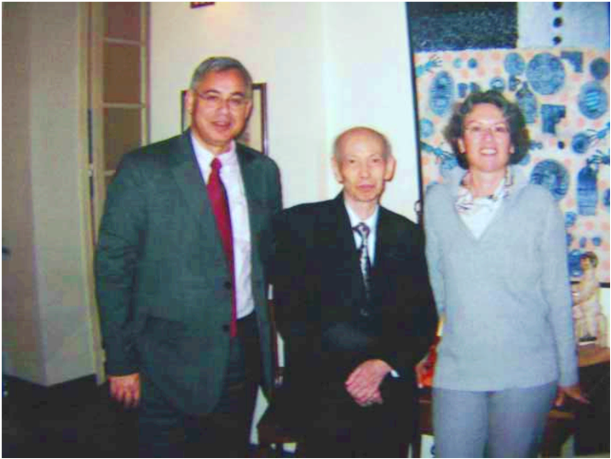
Musician Nguyen Van Quy and Ambassador Jean – Hubert Lebet and his wife
.
After this event violinist Nguyen My Huong said “I’m honored to play his composition. I learnt a lot when I was working with him. And I’m happy to perform a Vietnamese sonata!”. For this music night, violinist Isabelle Durin sent a congratulation letter to Nguyen Van Quy and the Ambassador read this in front of all the participants.
Before this event, in 2004 his works were performed in the concert “Music in sharing”. Ms. Isabelle Durin surprised the audience when she played Sonata No.7 together with support of pianist Tran Ngoc Bich, a lecturer of Hanoi Academy of Music in Hanoi. During that performance night some works of well-known French composers such as Camille Saint-Saëns, César Franck… were also played. This concert was organized at the concert hall of the Academy of Music (77 Hao Nam street, O Cho Dua ward, Dong Da district) on Saturday, 30th October 2004. The second performance was organized at the concert hall of Vietnam Musicians Association (51 Tran Hung Dao street, Hanoi) on 1st November 2004. This event was to commemorate 7th year of cooperation between the Francophone and Marie – Curie de Sceaux high school, Republic of France and Chu Van An secondary school (where Nguyen Van Quy once worked as a teacher).

In Vietnam no musicians have got such honor: a foreign artist came to Vietnam to play a Vietnamese composition.

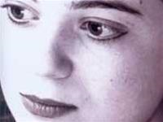
Two years later, at Hanoi Grand Theatre, on 16th February 2006 and French Cultural Centre (Institut Français de Hanoï), Ms. Isabelle Durin came back to Hanoi and played Sonata No.9. She put it “I realized the composer’s emotion in his music, the differences in the structure and melodies from other works I have played before. It has certain art quality and, therefore, I really want to play…He has created a style – unique and individual – I mean music is himself, distinguishable in a crowd”.

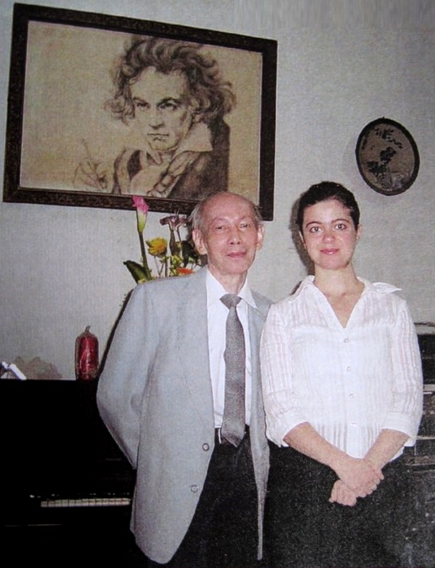
Musician Nguyen Van Quy and violinist Isabelle Durin at his home

Poems

His property has a small part for his poems composed when he was a music teacher. To understand further about him the audience can read from those works.
Xanh  Tôi vẫn thế và thấy đời vẫn thế  ngày xanh như chẳng hề phai đi  Và tình tôi thì vẫn còn xanh mãi  cùng nhành cây, ngọn cỏ… cứ xanh hoài.  Thu có về rồi thu cũng qua đi  lá úa vàng thì lá non thay thế  Cỏ xanh rờn, xanh tới tận chân mây,  Xanh của đất trời, xanh của cỏ cây.  Sóng lòng tôi dào dạt một màu xanh  Thật hiền hoà nhưng cũng rất mỏng manh  Sóng tan vỡ  những mảnh lòng tan vỡ,  Thời gian ơi! Xin đừng nỡ  Thờ ơ! | Green  I am still the same and life is still the same  Green day seems not to be fade  And my love will be green forever with tree branches, grass  Autumn comes and goes  Yellow leaves will be changed with younger ones  Grass is green, green to the end of the Earth  Green earth and sky, green plants  Waves in my heart are also green  Peaceful but also fragile  Broken waves  Broken hearts  Time! Don’t be so indifferent!

La belle sérénade

Khúc ca ban chiều êm đềm  Khúc ca ban chiều êm đềm  Mà thời gian xanh cẩm thạch  Để dành cho mọi trái tim rách nát  Đã giao cho dòng thác hát lên  Khúc ca ban chiều của mọi trái tim  Mơ tìm hạnh phúc  Muốn ôm ghì lấy những vì sao quá cao! có thể nào với được!  Thời gian trôi qua, xóa đi…  Nước dòng thác tuôn cuốn đi…  Tất cả đều chìm trong lãng quên,  còn ngân vang…  Khúc ca ban chiều êm đềm… | The lovely serenade  The lovely serenade  With the green jade time  For all broken heart  Make the waterfall sing!  The serenade of all hearts  Longing for happiness  Aspiring to extend to the stars  Too far to be theirs!  Time goes by, fading…  The stream from the waterfall fades…  All fall in obliviousness,  There rests the lovely serenade

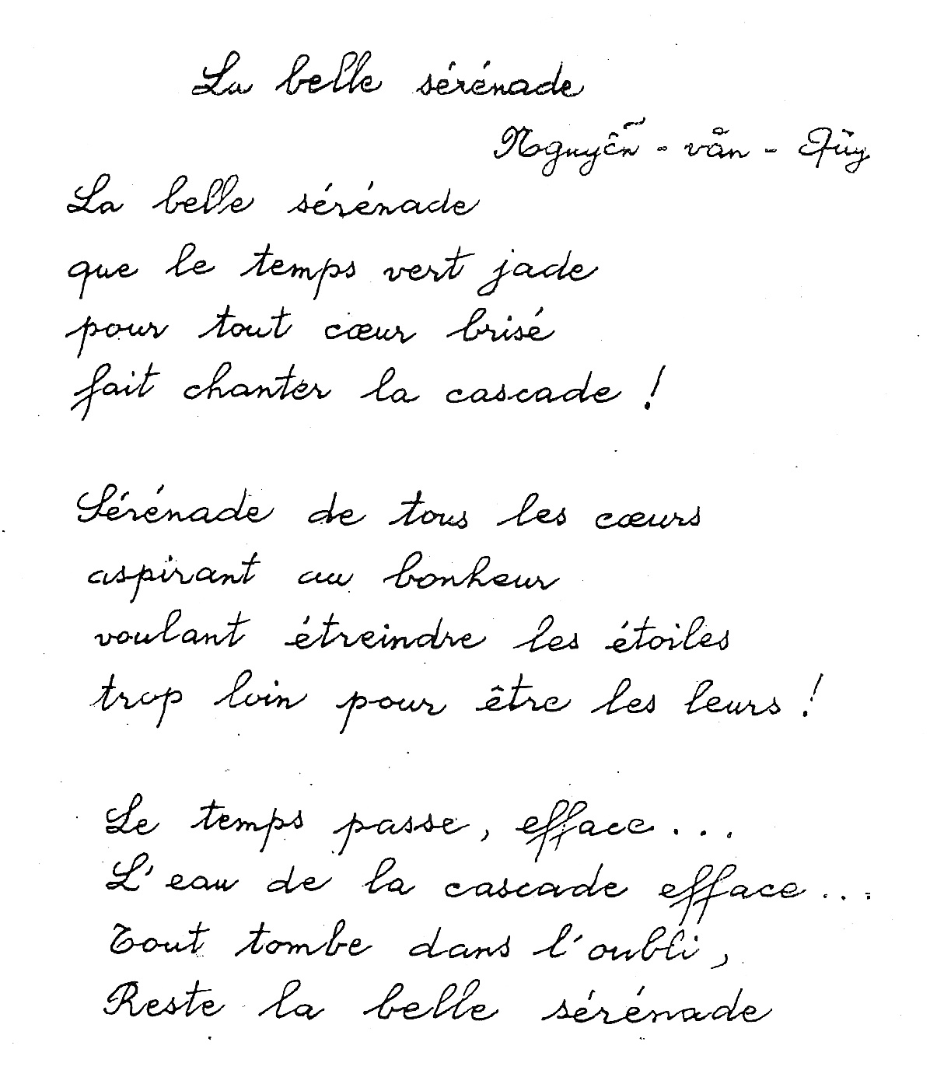

“The lovely serenade” was written in French

Nhớ anh  Nhớ anh trong chiều buông tím tím  Nhớ anh trong chiều sương giá lạnh  Nhớ anh, em thấy lòng cô quạnh  Và âm thầm em gọi mãi tên anh  Nhớ anh trong chiều xa quê hương  Nhớ anh trong chiều gió tha phương  Nhớ anh trong mối tình vô vọng  Và âm thầm em gọi mãi tên anh  Yêu anh, em ước làm hơi gió ấm  Êm đềm, em quấn quýt bên anh  Yêu anh, em ước làm đóa hoa  Cho hương thơm lan tỏa thấm lòng anh  Nhớ anh trong mùa gieo lá úa  Nhớ anh mây trời xám giăng mưa  Nhớ anh, năm tháng dù phai tàn  Còn âm thầm em gọi mãi tên anh | Missing you  Missing you when the violet casts a gloom over the evening,  Missing you all the evenings in the cold mist.  Missing you, I feel so lonely,  And I always whisper your lovely name to myself.  Missing you, away from homeland,  Missing you when the cold wind wonders in furry.  Missing you, knowing that there is no hope for my love,  And I always whisper your lovely name to myself.  Loving you, I dream of the warm blow,  Gently, I embrace you like a lovely coiled headband.  Loving you, I dream of being an embalmed flower.  Loving you, knowing that there is no hope for my love  So your heart, with its aroma, may be impregnated.  Missing you when the season comes strewing the yellow leaves,  Missing you when the grey sky makes the rain fall,  Even though the time goes by, missing you,  I always whisper your lovely dear name to myself.

This poem was translated from French. Aymeric Bas talked about his emotion: “Sir, your poem is the image of your music, charming, gentle, deep and new but belongs to all time. Thank you for your talent sharing”.
Another French man, Mr. Bernard also read this poem in French while a part of Movement 2 of Sonata No.6 was being played at the Patrimoenia 2009 prize awarding ceremony.

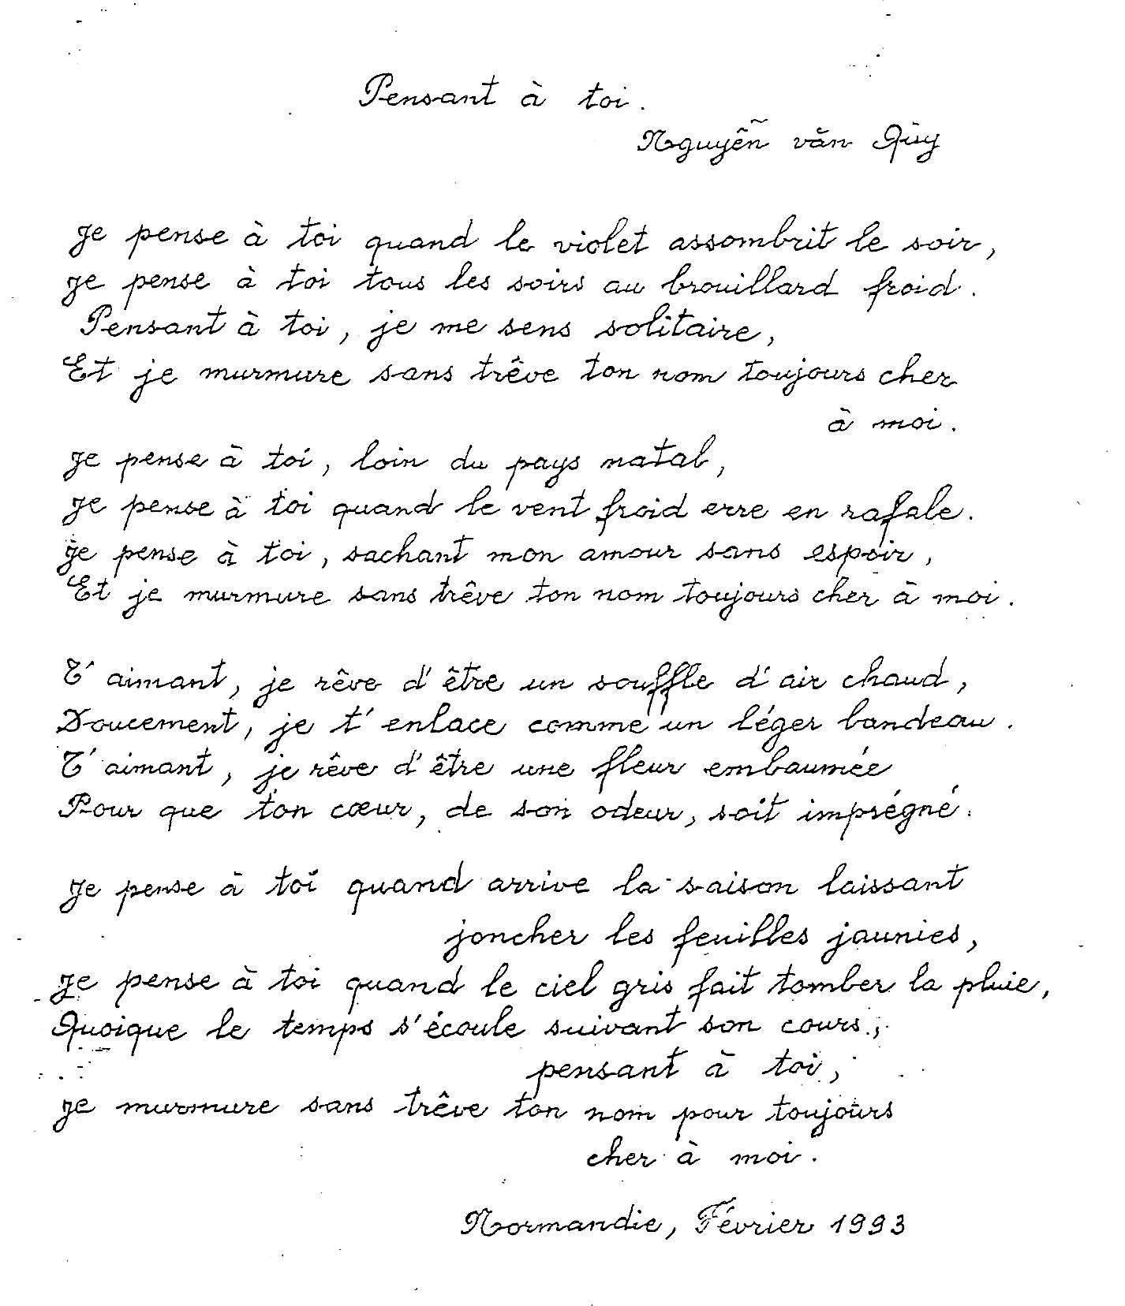
Although he did not compose many poems they have new art image and language. Especially, they have a combination between two literature currents, the domestic literature and French literature. Their words have the pure soul and cheerfulness of the French romantic literature but also the peacefulness and deepness of the Vietnamese literature. From this feature most of his poems were composed in both French and Vietnamese.
Unlike wordless music which is deeply sad here and there his lines of poetry has a optimistic and young soul and also self-satisfaction with the situation.

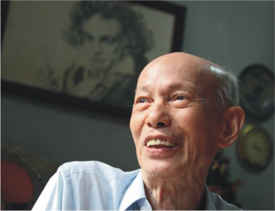
Poet Nguyen Van Quy with love for life

His poems also express the passionate love for nature. From the feeling of the fresh beauty of the nature, the kindness and solidarity in the human soul and hope for a bright future arise. This is revealed in one of his poems: The Nature:

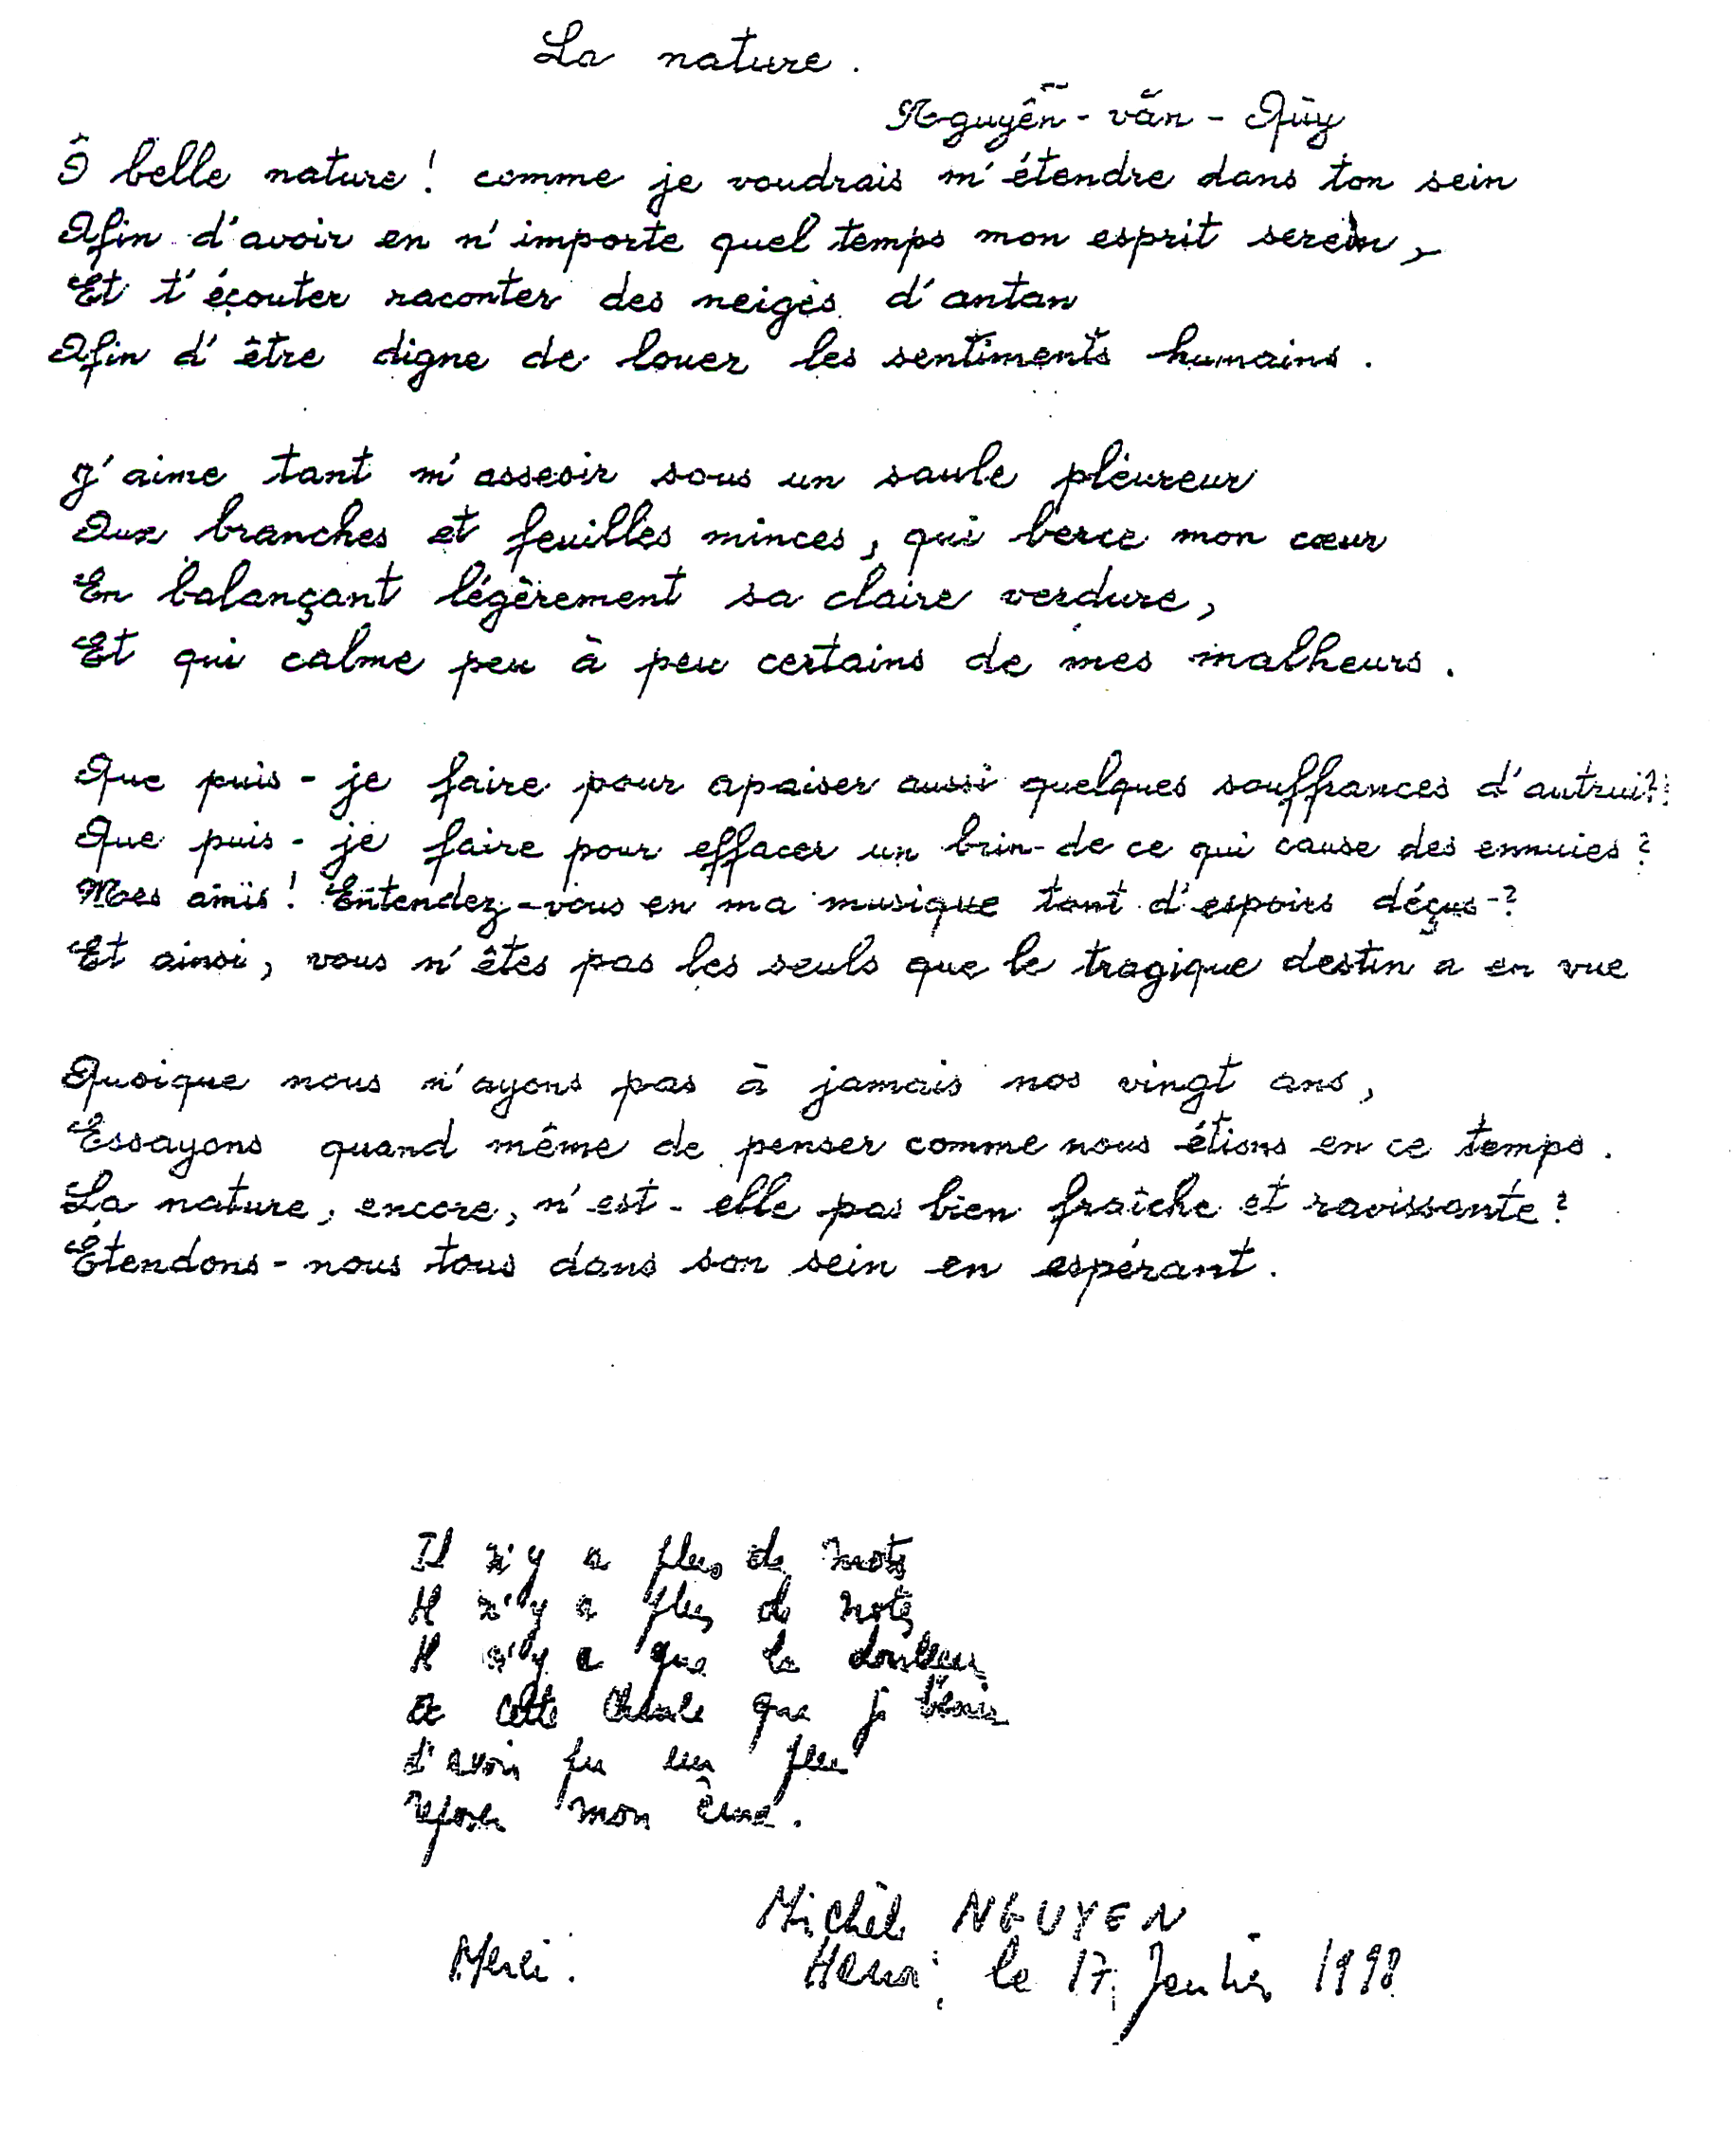

Thiên nhiên  Hỡi thiên nhiên đẹp đẽ! Tôi muốn ngả vào lòng thiên nhiên biết bao  Để có được trong bất cứ thời điểm nào tâm hồn trong sáng  Và nghe thiên nhiên kể về những điều đẹp đẽ xa xưa  Cho tôi được xứng đáng ngợi ca những tấm lòng nhân hậu.  Tôi yêu biết bao được ngồi dưới một cây liễu rủ  Có cành và lá mỏng manh, ru trái tim tôi  Trong khi đu đưa nhẹ nhàng vòm xanh của liễu  Và làm dịu dần một vài nỗi đau trong tôi  Tôi biết làm gì đây để cũng làm dịu đi một vài nỗi đau của đồng loại?  Tôi biết làm gì đây để xóa đi đôi chút nguyên nhân của những buồn phiền?  Các bạn của tôi ơi! Các bạn có nghe thấy chăng trong âm nhạc của tôi biết bao là hy vọng bị tàn lụi?  Và như vậy các bạn đâu phải là những người duy nhất mà định mệnh đau buồn đang nhằm tới  Dù chúng ta không mãi mãi ở tuổi hai mươi  Chúng ta hãy cứ thử suy tư như chúng ta còn ở thời điểm ấy  Và thiên nhiên còn kia không thực là tươi tắn và đẹp đẽ hay sao  Tất cả chúng ta hãy ngả vào lòng thiên nhiên và hy vọng | The nature  Hey lovely nature! I wish to be embraced in your breast  To have my transparent spirit at any time,  And listen to your story about snow in yesteryear  To deserve the humane sentiments.  How I love to stay under a weeping willow  With the slim branches and leaves that teeter my heart  While gently balancing their clear greenness,  And ease a bit of my unhappiness.  Then what should I do to partly ease what others are suffering!  Then what should I do to erase a fiber of the cause for boredom?  My friends! Could you hear my music with the disappointed hope?  And friends, you are neither the people approached by the dramatic destiny  Even though we are not in our twenties forever,  Let’s try to think as if we are in those ages.  Isn’t it - the nature - still so fresh and lovely!  Let’s all stay in its breast and hope.

After listening to Sonata No.3 and reading The Nature, a French-Belgian writer, Mr. Michèle, was moved and wrote: “No more words, no more music, only gentleness and luckiness make my soul quiet for a while. Thank you!”

About the natural beauty, but the nature at night, the poet also has another short poem titled Dạ lan (Hyacinth). The poem is about the feeling of the miraculous fragrance of such a flower which only smells at night and only delicate soul can absorb it. In this poem the writer also says for the people with broken love that still exists in their recollection.
Dạ lan is praised by a lot of poetry lovers as it is impressive. It was composed in Hanoi during August 1998.
Dạ lan | Hyacinth
Dìu dịu hương hoa  Mơ hồ lan tỏa  Hương từ đâu?  Tỏa về đâu?  Khiến lòng tôi dịu bớt u sầu.  Tưởng như thấy lại em  Trong hương hoa ban đêm,  Hay là trong giấc ngủ?  Tôi tỉnh hay tôi mơ?  Ôi! cho tới vô biên tôi vẫn đợi chờ. | Fine smell  Vaguely spreading  Where is smell from?  Where smells goes?  It helps relieve my meloncholy.  It seems I found you  In smell during the night  Or in sleep?  Am I awake or dreaming?  Wow! I’ll wait for ever.

Feedback and appreciation
Despite his devotion of the whole life for music and achievement of great prizes he does not want to be promoted to a high position or level in the Vietnamese music. Above any title, his works have reached the peak of academic music. All of his nine sonatas have been recognized to be unique and it is important that he is mentioned with admire and respect by his friends and music lovers. For a human life, this is more valued!
About him, a lot of local and foreign artists give him admiring words and are proud to call him a great teacher, a great friend. His name accompanies with lovely titles : Quy serenade, Quy sonata, Beethoven Vietnamien, famous teacher Nguyen Van Quy, master... When his sonatas were played in France the audience compared him to a Beethoven of Vietnam. The 14th February 2007 issue of Le Courrier Du Viet Nam – the only French daily newspaper in Vietnam, issued by Vietnam News Agency quoted remark of Dr. Tarique Farrooqui – UNICEF Representative in Vietnam - after he listened to a sonata: "Le Vietnam se heurte à maintes difficultés, mais avec la sonate N°4 de Nguyên Van Quy, les Vietnamiens en général et l''auteur en particulier peuvent être fiers de leur musique nationale” (Vietnam is still facing a lot of difficulties but with this Sonata No.4 Vietnamese in general and you in particular can be proud of your national music”.
Mr. Tarique Farroqui requested Nguyen Van Quy to give it to the leader conference of big nations for approving the convention on child right protection. After this conference the composer received a thank-you letter from the US. During his term in Vietnam, Dr. Tarique Farooqui came to Nguyen Van Quy to listen to his sonatas with admiration.
Watching the music disks and the disks recording the performance of his sonatas, listening to his piano, feeling manner of a Vietnamese person talking about his own music, looking at the foreigners’ respect toward his compositions the audience will certainly feel more about Nguyen Van Quy and the foreigners’ truthful appreciation as well as admiration for him.
Violinist Isabelle Durin came to Hanoi twice in 2004 and 2006 to play Sonata No.7 and Sonata No.9 and said « these works enhance the national position and pave a new music horizon to speak to the mankind ». She also remarked another time that he was not rarely called Beethoven of Vietnam.
His hard work for creation has spread quickly and strongly to a lot of foreign friends. German pianist Dominic Jehle came twice to his home to listen to Sonata No.5 and Sonata No.8 and said « This is genius – génial” and called him Maestro – master. In a letter sent to Nguyen Van Quy, he wrote « Your music hypnotized me and engraved my mind. This music has great art value!”
During his three visits to France, Ms.Bertile Fournier said “Quy has created new language of music!” She expressed her cheerfulness at his contributions to the music of Vietnam. In her letter to Nguyen Van Quy on 16th March 2001, she wrote « Dear Quy, I’m listening to your Sonata No.6 and thinking about you specially, about your ever-diversified and attractively romantic inspiration.”
After listening to Sonata No.8 and Sonata No.9 and studying the scores, a French musician Paulette Kappweiler remarked «His music is really sublime!".
In Vietnam, a lot of musicians and artists have performed or enjoyed his works. They always respect and pride of performing Sonatas of Vietnam.
Musician Do Hong Quan, Chairman of Vietnam Musicians Association once stated : “Musician Nguyen Van Quy is an example of creative work and love for music. He is a Great Artist with its capitalized meaning. Vietnamese artists recognize his whole-life contribution to the national music ”.
Professor Ngo Van Thanh who has played successfully many of Nguyen Van Quy’s sonatas in Vietnam and overseas put it “Musician Nguyen Van Quy is a talent. His works are always expressed with strong emotion. They were written in Western-style structure but presented very Vietnamese soul, in a particular language of music. Especially, he has composed a lot of beautiful movements 2 with deep emotion …”
Musician and researcher Nguyen Thuy Kha wrote “As a witness, with his writing he told from the bottom of his heart the torment of a time, of the nation and mankind. And, therefore, it spreads forever in the human life”.
Participating in the awarding ceremony at the Embassy of Switzerland, Mr.Duong Trung Quoc – General Secretary of Vietnam Historical Science Association uttered “This is an unforgettable evening for the emotion from music”.
At this event, artist Chieu Xuan said “As a silent statue, he has defeated time and life by his love for music. His music was like a poem and his poetry resounds as a pure melody. Thank you !”.
Mr.Adam, from Poland, a connoisseur of various music styles (classical, romantic, impressive and modern) wrote “Thank you for the moment when sentiments and emotions harmonize, touch hearts and go beyond boundary and time. His music is unique and will spread for ever”.

Conclusion

Selecting harmony music and sonata composition means to select a quiet way, a poor and dedicative life, especially in the context that most of the population has not been trained on enjoying great music. At the age of 87 he is still going alone on his way with 9 sonatas. But he does not feel regretful. Although he has never organized recording of his works with a symphony orchestra his music will not be “quiet to wait for time to support” (as written in the introduction of Nguyen Van Quy - His Works, published in Hanoi in 2010. This book introduced the composer and his works honestly).
The mentioned book includes all the nine sonatas and 12 songs composed by Nguyen Van Quy. The author of the introduction part intentionally hidden valued rewards and success of Sonatas No.6, 7, 8 and 9 while these compositions had been recognized and highly appreciated. Sonata No.8 was recorded by the Voice of Vietnam, sent to a competition, and got the second prize (no first prize was decided that year). Its Movement 2 was played at Hanoi Grand Theatre on the National Day 2010. German pianist Dominic Jehle listened to it, read the score and then remarked that it was genius. Ms. Bertile Fournier specially liked Sonata No.6 and considered it a completely new language of music. Violinist Isabelle Durin came to Vietnam twice to play Sonatas No.7 and No.9. Sonata No.8 is also praised by the public to be the most lyrical and cheerful among the nine sonatas.
In other words, the introduction of the book is not deserving the content which presents successful works of musician Nguyen Van Quy. The writer of that introduction was described by some newspapers with such words as envious, begrudging …

With difficult childhood and quiet life at old age, he has experienced hard work, scorn, blocking... but his noble personality has never been eroded.
He is now living so modestly at No.13 Nguyen Quang Bich street. By the old piano under large-size L.V. Beethoven portrait, he feels satisfied with his life. His most valuable property is the nine sonatas. Besides the scores kept and recorded at the Voice of Vietnam, those sent to overseas friends and introduced in some other countries... he is maintaining all the others left in the cabinet to show to his foreign friends and music fans when they come to visit him. His hands and eyes now prevent him from playing or composing music but his stories about music remain magically wise and passionate! His eyes get brighter when hearing someone talk about variation, creation and uniqueness of music.
My dear audience! Each artist, particularly each composer, is a boundless world. To understand and feel about them we have to not only go deep into their life and compositions but also learn the their secrets. I have not done this so far! However, after a lot of talks with him at his home I understand him more than many others. And that teacher and musician has brought and taught me a lot of things.
This booklet is important not only for the musician. For me it has great spiritual value and I hope that the readers think so. I would like to have a small request that the readers should learn more about sonata music, listen to Nguyen Van Quy’s sonatas with special emotion and pure intelligence while you have this booklet on hand. If the readers have no understanding about sonatas or vague understanding about this wordless music they can just read raw words and cannot understand well the master musician himself. If the readers understand sonatas, music for instruments and tune of sonatas they will feel in mind another world and the efficiency will multiply. It is also because my words cannot replace his beautiful music.
I myself have tried various times listening to his music and felt new, amorous, sad and dreamy emotions. They are something above my real life and from above his music radiates strange halo. His music sweeps away the dark side of the soul and lights a cosy fire in my heart. Maybe later if I come to music sector because of some reason in life I will consider musician Nguyen Van Quy as my top of music.
40 years ago he drived a Mobylette from No.13 Nguyen Quang Bich to Hanoi Teaching College to teach in Cau Giay district. And now I am so lucky to go back from Cau Giay district to his home to do completly different work: to write this book. I have gone on the road he went before, but opposite way and back in time to find him, a man in the crowd during difficult time bringing his own grieves... He is now an 87-year-old musician with a lot of prizes and honorable names.
And, after understanding about him I started to write, very passionately…
In the final part of this booklet I would like to rank him after a lot of worldwide talents of music, e.g. Johan Sebastian Bach, Joseph Haydn, Wolfgang Amadeus Mozart, Lugwig Van Beethoven, Franz Schubert, Robert Schumann, Tchaikovsky... It is because with their gifted music capacity and hard work for searching the beauty of sound they have contributed to the mankind their immortal works beyond space and cultural barriers, and, so far, their works are still considered "classical" and have fadeless value. As remarked by ex-General Secretary of Vietnam Musicians Association : “Nguyen Van Quy’s compositions will exist...forever!”
Hà Nội, July 7/2011
Writer: Nguyen Trâm
Email: tramnguyen87@gmail.com
Tel: 01683 937 363

Special thanks

Ms. Nguyễn Trâm writing this biography in Vietnamese
Mrs. Lê Thị Thanh Thảo and Mr.Alain Chevalier for the English translation
Mrs. Marie Lahouati for the French translation from English
Mr. Matthieu F. for the editorial review

Thanh Hoa province is located in the Central region, about 150km south Hanoi.
Ninh Binh province is located in the south of the North region, about 100km from Hanoi
1 Nam Dinh province is located in the south of Northern Delta, 90km from Hanoi.
1 Hoang Minh Giam (1904 - 1995) was a Vietnamese diplomat. He was Minister of Foreign Affairs, Minister of Culture, Chief of Committee for Foreign Affairs, a member of the Naitonal Assembly…
1 Đặng Phúc Thông (1906-1951), a patriotic intellectual, one of the first Vietnamese trainees in France. He graduated with excellent results 2 big universities in Paris: Mining University, and Brige and Road University. After coming back to Vietnam he took various important positions such as Deputy Minister of Public Works and Director of Vietnam Railway, directly commanded trains carrying food and soldiers to the South of Vietnam during 1945 and 1946; participated in negotiations at Fontainebleau Conference; was Director of Civil Engineering University. He was appreciated by President Ho Chi Minh as an excellent senior official of the Government and a loyal soldier of the nation.
2 Ho Dac Lien (1904-1958): a mineral engineer, graduated mining speciality in Paris, the first General Director of the General Department of Geology. He was Director of Geology Bureau (it later became General Department of Geology) between 1955 and 1957 when he died.
1 Chu Van An senior secondary school (also named Chu and Buoi school) was a public school in Hanoi. Established in 1908 it is now one of the top-ranking schools. A lot of Vietnamese talents were educated at this school.
2 Hanoi Teaching College was established on 6th January 1959. It trains teachers for primary and junior secondary schools in Hanoi as well as other provinces/cities.
1 Page 63, Book “36 Hanoians”
1 Lily Laskine is a music association established in accordance with French legislation in 1991 by students of a female artist, Ms. Lily Laskine (1893 - 1988) – one of outstanding harpists of the twentieth century. She was a professor of harp at Paris Academy of Music. Since 1993 the association has mainly organized international competitions of harp performance, every 3 years. Not only young harpists but also well-known harpists participate in such competitions.
The People
Communist Magazine
1 Song “Love profession as much as people” by musician Nguyen Van Quy
Serenade
Sunset
Rural girl in the afternoon
Remembering the moonlight
Love profession as much as people
Floating cloud
Two banks
Hurrah liberalization soldiers
Liberalized Hanoi
Uncle Ho – our sunlight
Rising tide
Young people on construction site
The capital follows Uncle Ho
Love Vietnam flag
Under blue sky
1 Sa Pa is a mountainous town, a famous sight-seeing place of Sa Pa district, Lao Cai province, Vietnam. It possesses a lot of natural miracles. It is populated by various ethnic minority groups.
1 Ludwig Van Beethoven (1770 - 1827) was a German talent musician who composed a lot of symphonies and sonatas familiar to audience worldwide for centuries. His contemporary artists called him an “eccentric genius” as he always created eccentric sound and with sudden inspiration. Most of his works are played worldwide.

