Universe & Earth
14 Gy |  | 13 Gy | 12 | 11 | 10 Gy | 9 | 8 | 7 | 6 | 5 Gy |  |  | 4 |  |  | 3 |  |  | 2 |  | 1 Gy
eons: |  |  |  |  |  |  |  |  |  |  | Hadean |  |  | 3.8 Achaean |  |  | 2.5 Proterozoic |  |  |  |  | Phaner.
 | ~13.8 Big Bang |  |  |  |  |  |  |  |  |  | 4.6 Sun & Earth |  |  |  |  |  | 2.5 oxygen |  |  | 1.2 sex |  | 0.5  Verteb.
 |  | ~13 Milky way galaxy |  |  |  |  |  |  |  |  |  | 4.5 Moon |  |  | 3.6 Life prokar. |  |  | 2.1 Life eukaryotic
Big 5 mass extinctions:
Vertebrate Life
500 My |  |  |  |  | 400 My |  |  | 300 My |  | 200 My |  | 100 My | 65.6 My |  |  | 2.6
Palaeozoic era |  |  |  | 400:insects 380:land animals |  |  |  |  | Mesozoic, 230:dinosaurs 150:birds 130:flowers |  |  |  | Cenozoic era
Camb. | Ordovician | Silurian | Devonian period |  |  | Carboniferous |  | Permian period | Triassic period | Jurassic period | Cretaceous period |  | Paleogen |  | Neogen | 4th
Laurentia, Gondwana, Avalonia, Baltica, Siberia continents |  |  |  |  |  |  |  | Pangaea supercontinent |  | Laurentia-Gondwana split |  |  |  | Current continents

Human Species & Hominids
4 My |  | 3.5 My | 3 My |  |  | 2.5 My |  | 2 My |  |  |  | 1.5 My | 1 My |  | 0.5 My | 0.15
Pliocene epoch (Neogen period) |  |  |  |  | 2.6 Pleistocene epoch |  |  |  | 1.9 Homo Erectus 1.5 fire |  |  |  |  |  | 0.5 H. Antecessor
 |  |  |  |  |  |  | 2.3 Homo Habilis (tool) |  |  | 1.8 Calabrian age |  |  |  | Ionian age | Neanderthal
 | 3.6 Australopithecus afarensis |  |  | Australopithecus africanus |  |  |  |  |  |  | Australopithecus robustus

150 ky | 140 | 130 | 120 |  | 110 | 100 ky |  |  | 90 |  |  |  | 80 |  |  | 70 |  | 60 | 50 ky | 40 | 30 |  | 20 |  | 10 |  |  | 0
 |  |  |  | Ice age |  |  |  | Ice age |  |  |  | Ice age |  |  |  |  | Ice age
Homo Sapiens Sapiens (modern man)  Earliest findings in Africa |  |  |  |  |  |  |  |  |  |  | Cloth |  |  | 75k Toba eruption  Man in India and Australia |  |  |  |  | Cro-Magnon man in Europe |  | Man in N. America |  |  |  |  | Agri. | Civ. |  | 2 000
Neanderthal in Europe |  |  |  |  |  |  |  |  |  |  |  |  |  |  |  |  |  |  |  |  |  | 25 k Neanderthal extinct
Modern Man

 |  |  | zodiacal ages: |  | 19.5 | 17.3 | 15.1 |  | 12.9 |  | 10.8 |  | 8.6 |  | 6.5 |  | 4.3 |  | 2.1 | 0 |  | 2.1 |  | 4.3
35 000 |  | 30 000 | 25 000 | 20 000 |  |  |  | 15 000 |  |  |  | 10 000 |  |  |  | 5 000 |  |  |  | 0
Pleistocene epoch (continued) end of last ice age |  |  |  |  |  |  |  |  |  | 11 700 Holocene epoch
 | Palaeolithic |  |  |  |  |  |  |  |  | Mesolithic |  |  |  | Neolithic |  |  |  | 3.7 k Bronze |  |  | 2 000
Sea level: |  |  |  |  |  |  |  | 100m lower |  |  | 50m lower |  |  |  | Same as today’s |  |  |  |  |  |  |  | 2m rise?

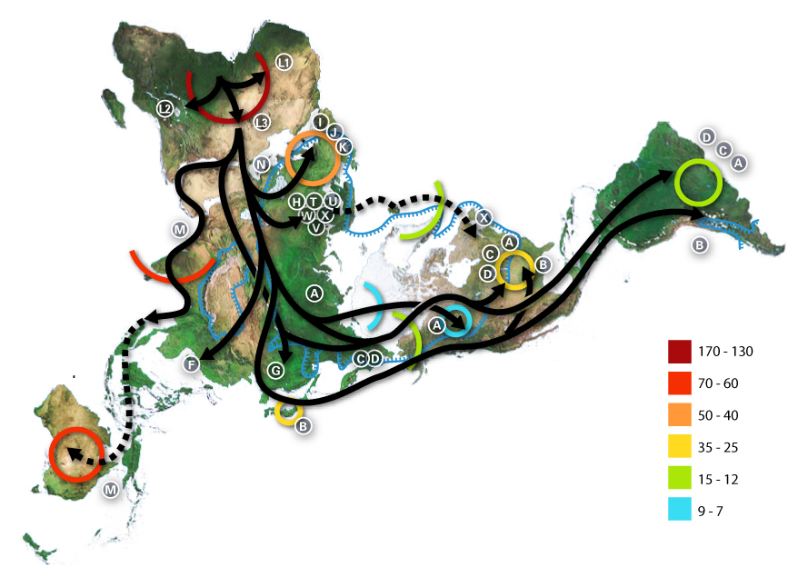
Letters represent the mitochondrial groups
Modern man migrations thousand years BC:

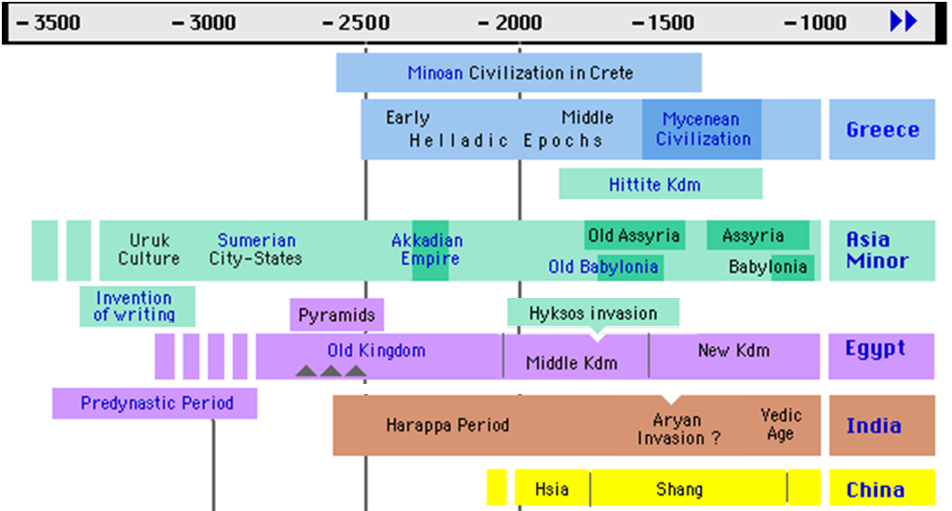

 |  |  | -3 500 |  |  |  |  |  |  |  | -3 000 |  |  |  |  |  |  |  |  |  | -2 500 |  |  |  |  |  |  |  |  | -2 000 |  |  |  |  |  |  |  |  |  |  | -1 500 |  |  |  |  |  |  |  |  |  |  | -1 000
 | 3.6 |  |  | 3.4 | 3.3 |  | 3.2 |  | 3.1 |  |  |  | 2.9 |  |  | 2.8 | 2.7 |  |  | 2.6 |  |  | 2.4 |  |  | 2.3 | 2.2 | 2.1 |  |  |  | 1.9 |  | 1.8 |  | 1.7 | 1.6 |  |  |  |  |  |  | 1.4 | 1.3 |  |  |  | 1.2 | 1.1 |  |  | 0.9
 |  |  |  |  |  |  |  |  |  |  |  |  |  | Gilgamesh |  |  |  |  | Cheops |  |  |  |  | Sargon I |  |  |  |  | Shulgi |  |  |  |  |  | Hammurabi |  |  |  |  |  |  |  | Akhenaton
← -4 000 Creation (Bible) |  |  |  |  |  |  |  |  |  |  |  |  |  |  | Menes |  | Imhotep |  |  |  |  |  |  |  |  |  |  |  |  |  | Senusret |  |  |  |  |  |  |  | Thutmosis III |  |  |  |  |  |  | Ramses II
Adam’s death |  |  |  |  |  |  |  |  |  |  |  |  |  |  |  |  |  | Djoser |  |  |  |  |  |  |  |  |  |  |  |  |  |  |  |  |  |  |  | Minos |  |  |  |  |  |  |  |  |  | Agamemnon
 |  |  |  | Enoch |  |  |  |  | Lamech |  |  |  |  |  |  |  |  |  |  |  |  | Shem |  |  |  |  |  |  |  | Abraham |  |  |  |  | Joseph & Levi |  |  |  |  |  |  |  |  |  |  |  | Moses (historical)
 |  | Jared |  |  |  | Methuselah |  |  |  |  |  | Noah |  |  |  |  |  |  |  |  |  |  |  |  | 2344: Flood (Bible) |  |  |  |  |  |  | Isaac |  |  |  |  |  |  |  |  |  | Judges time |  |  |  |  |  |  |  |  | David
 | Mahalaleel |  |  |  |  |  |  | 3113 Aug 11th: Maya long count start |  |  |  |  |  |  |  |  |  |  |  |  |  |  |  |  |  |  |  |  |  |  |  |  | Jacob |  |  |  |  |  |  | Moses (Bible) |  |  |  |  |  |  |  |  |  |  |  | Solomon
 |  |  |  |  |  |  |  |  |  |  |  |  |  |  |  |  |  |  |  |  |  |  |  |  |  |  |  |  |  |  |  |  |  |  |  |  |  |  |  |  | Man in Madagascar and New Zealand
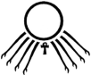
商

Kush Kingdom in Sudan
Trojan war
Mitanni
2350 - 2150
3500 ------------------------------ 2900
夏
甲骨文
Script
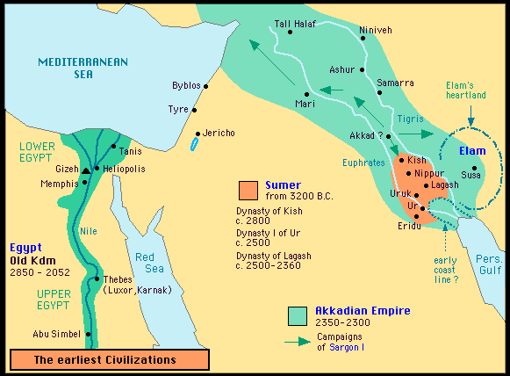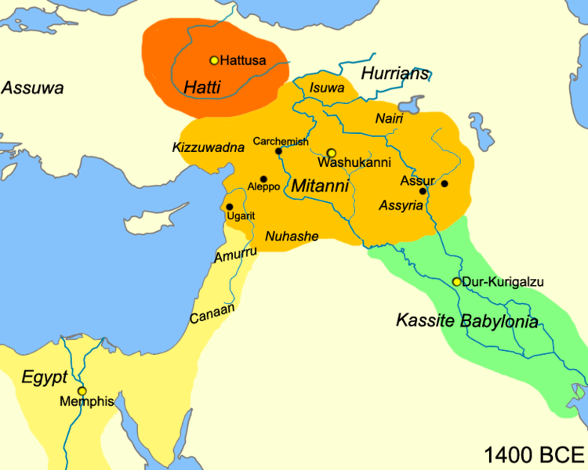
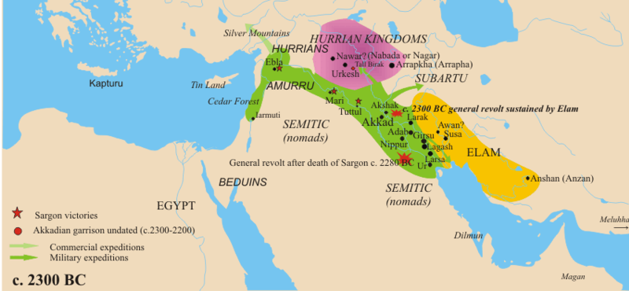
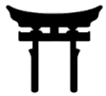
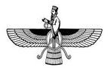
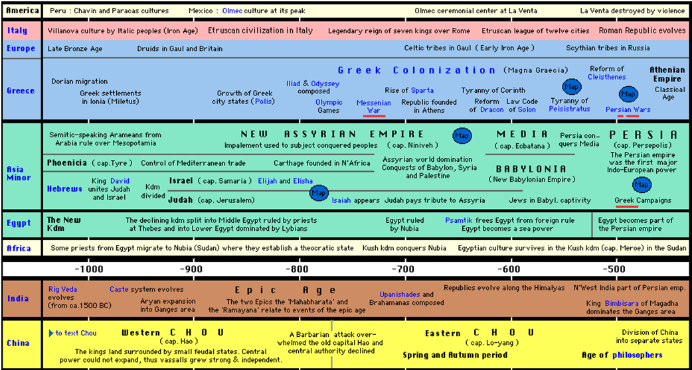
周
周

Buddha
金文
Script
Confucius 孔子
Lao Zi 老子
Mahavira (Jainism)
Cyrus II free Jews
Zarathustra?

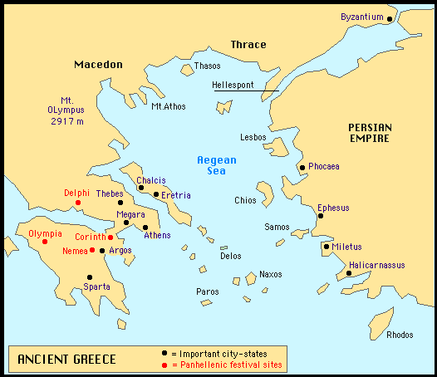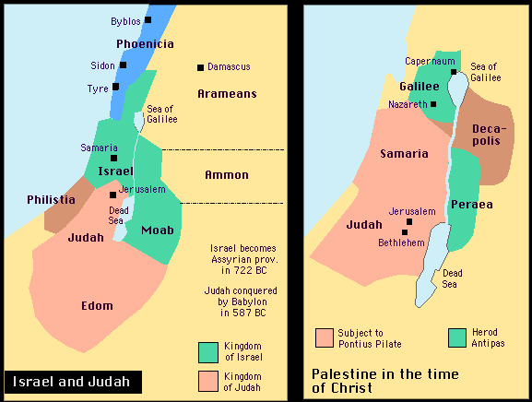
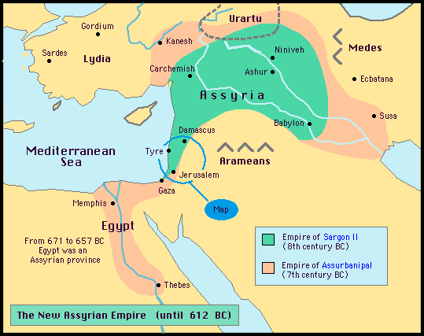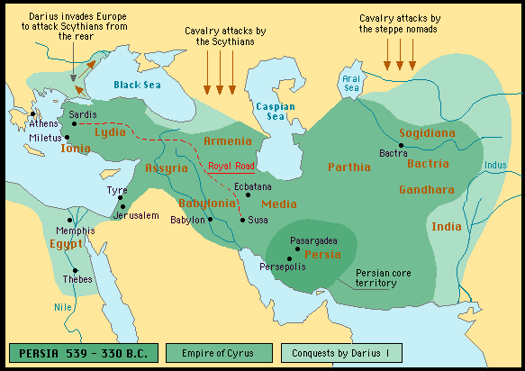
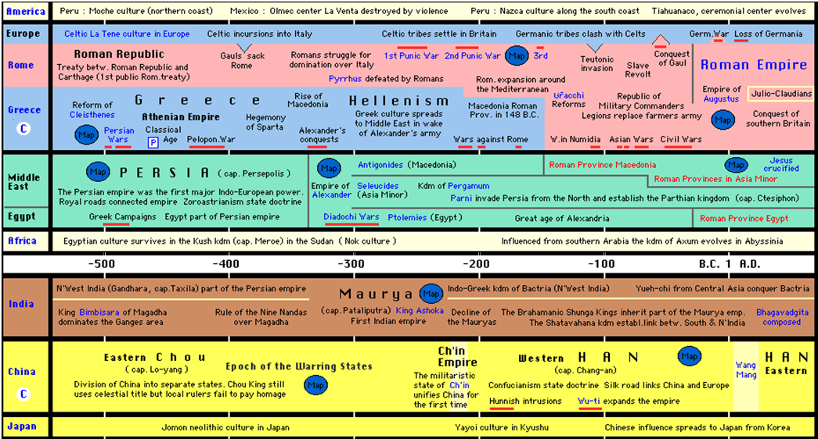
战国
1st Chinese domination
赵Triệu dynasty
蜀Thục
Semi-legendary Hồng Bàng dynasty, founded by Hùng Vương in 2879 BC
Viet.
周
秦
汉
Plato
Socrates

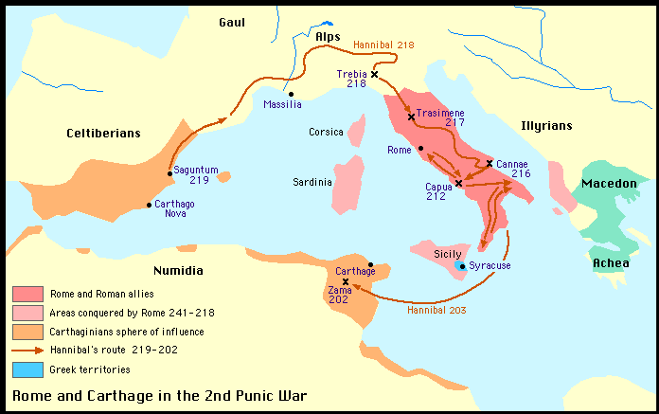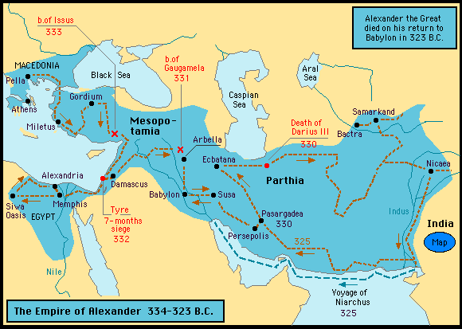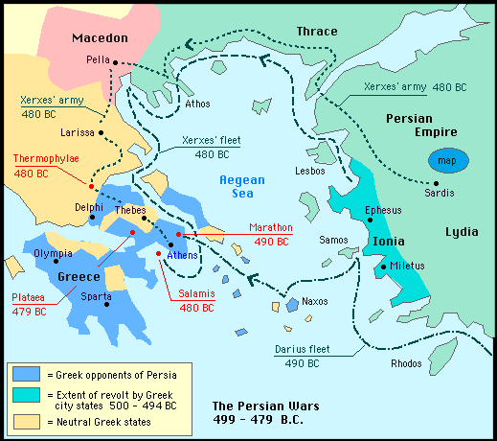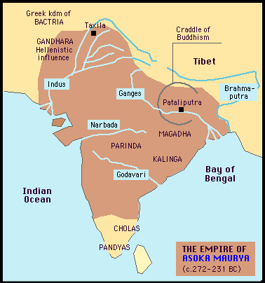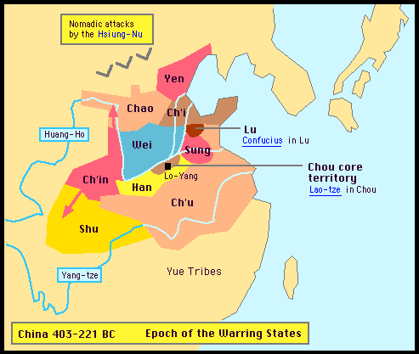

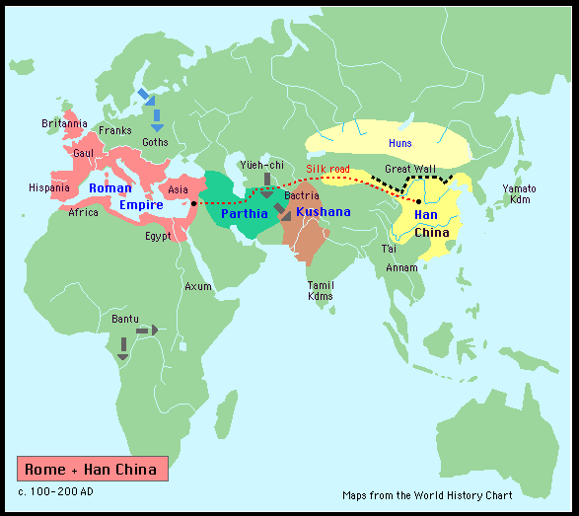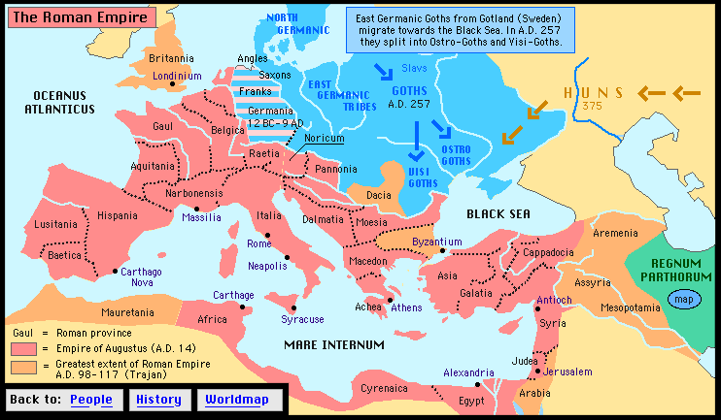

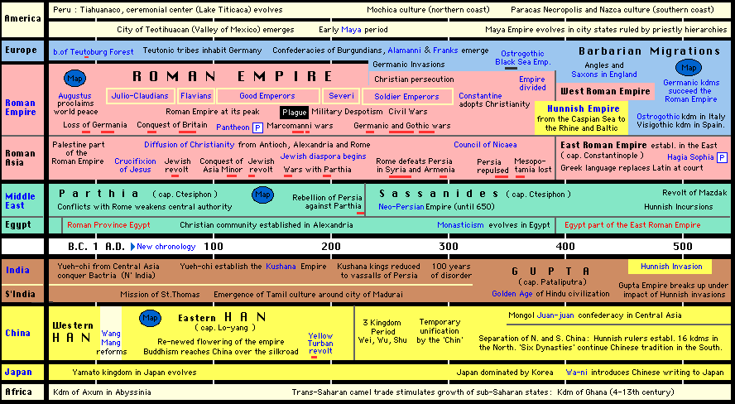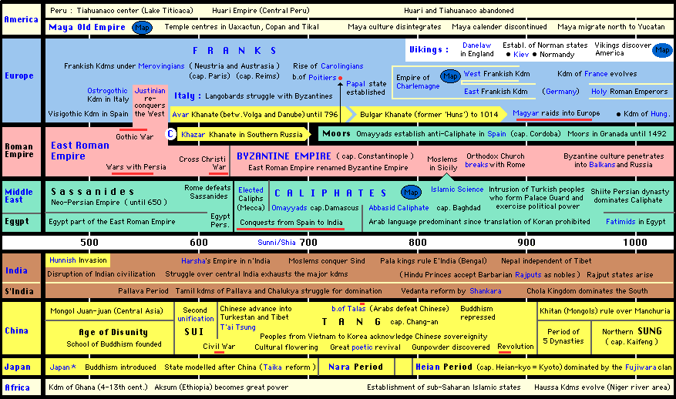
Merovingians
大和
晋
魏吴蜀
三国
汉

Viet.
Hai Bà Trưng
1st Chin. dom.
2nd Chinese domination over Vietnam
Khmer  Capetians  Carolingians  辽  隋  唐 |  |  |  | Isav. I | Jayavarman I | Jayav. II | Angkor: Indravarman I |  |  |  | Jayavarman V
Vietnam | 2nd Chinese dom. | Early Lý | 3rd Chinese domination over Vietnam |  |  |  |  |  | Ngô | Đinh |  | Lê anter.

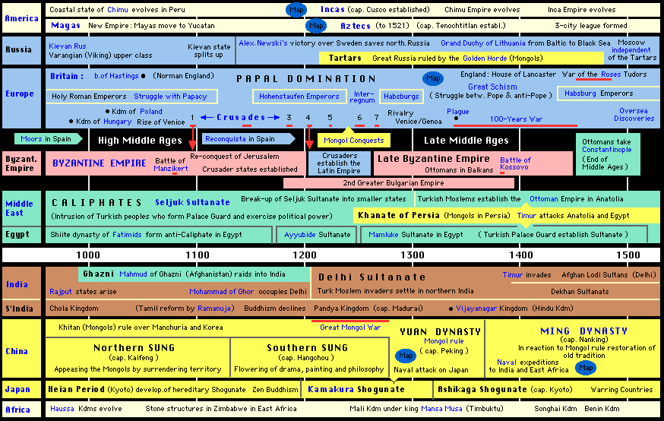
Valois
金 Jin jurchen
元
宋
明
Guru Nanak
Khmer |  |  | Angkor vat: Jayavarman VI | Bayon (Buddhism in): Jayavarman VII |  | End of Angkor
Vietnam | Lê anter. | 李Lý dynasty in Vietnam |  |  | 陳Trần dynasty in Vietnam |  | 4th Chin. |  | 黎Lê dynasty
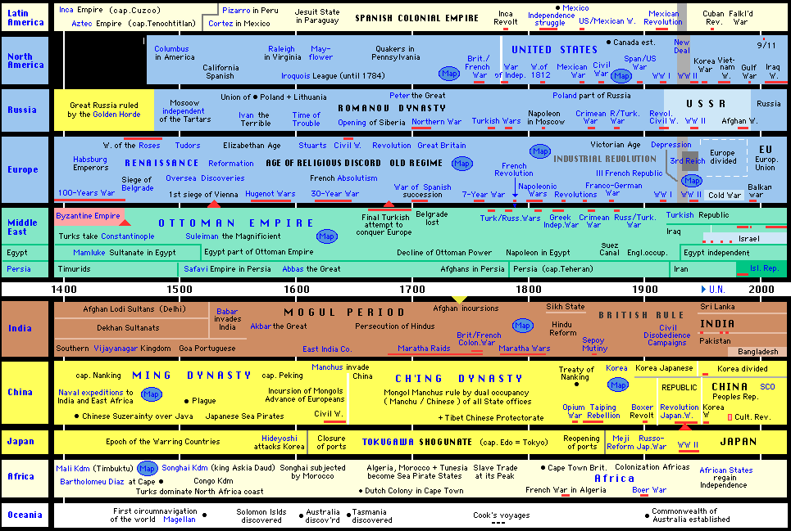
Matteo Ricci
Bourbons
明
Vietnam | 黎Lê dynasty (continued) | 莫Mạc | Lê restored | 阮Nguyễn dynasty
 |  |  | Nguyễn lords Quang Trung  DeRhodes |  | French colony
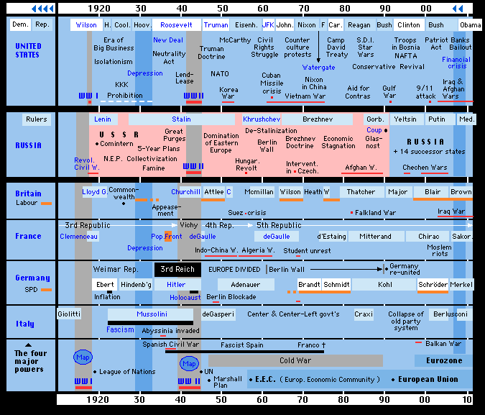
清
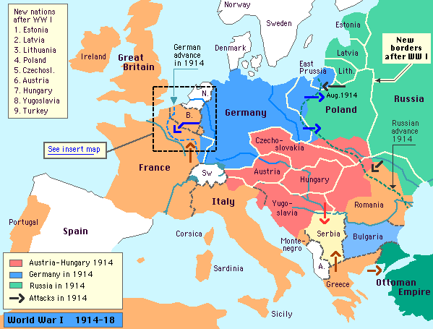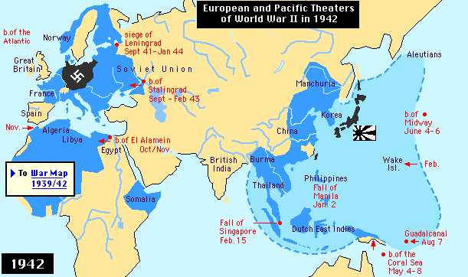
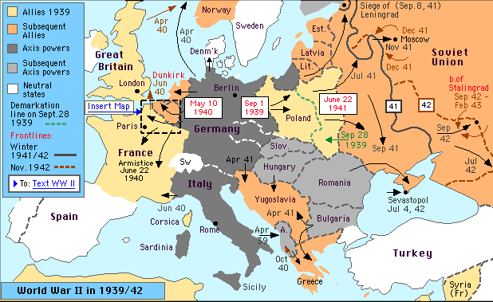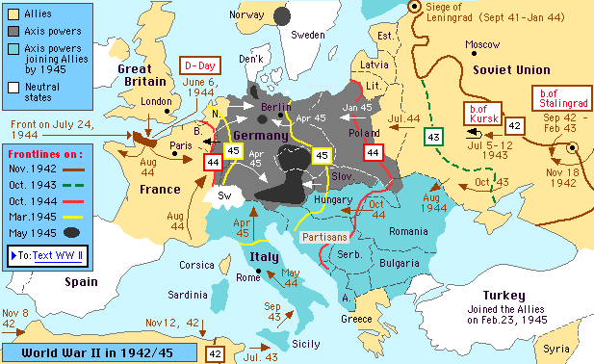

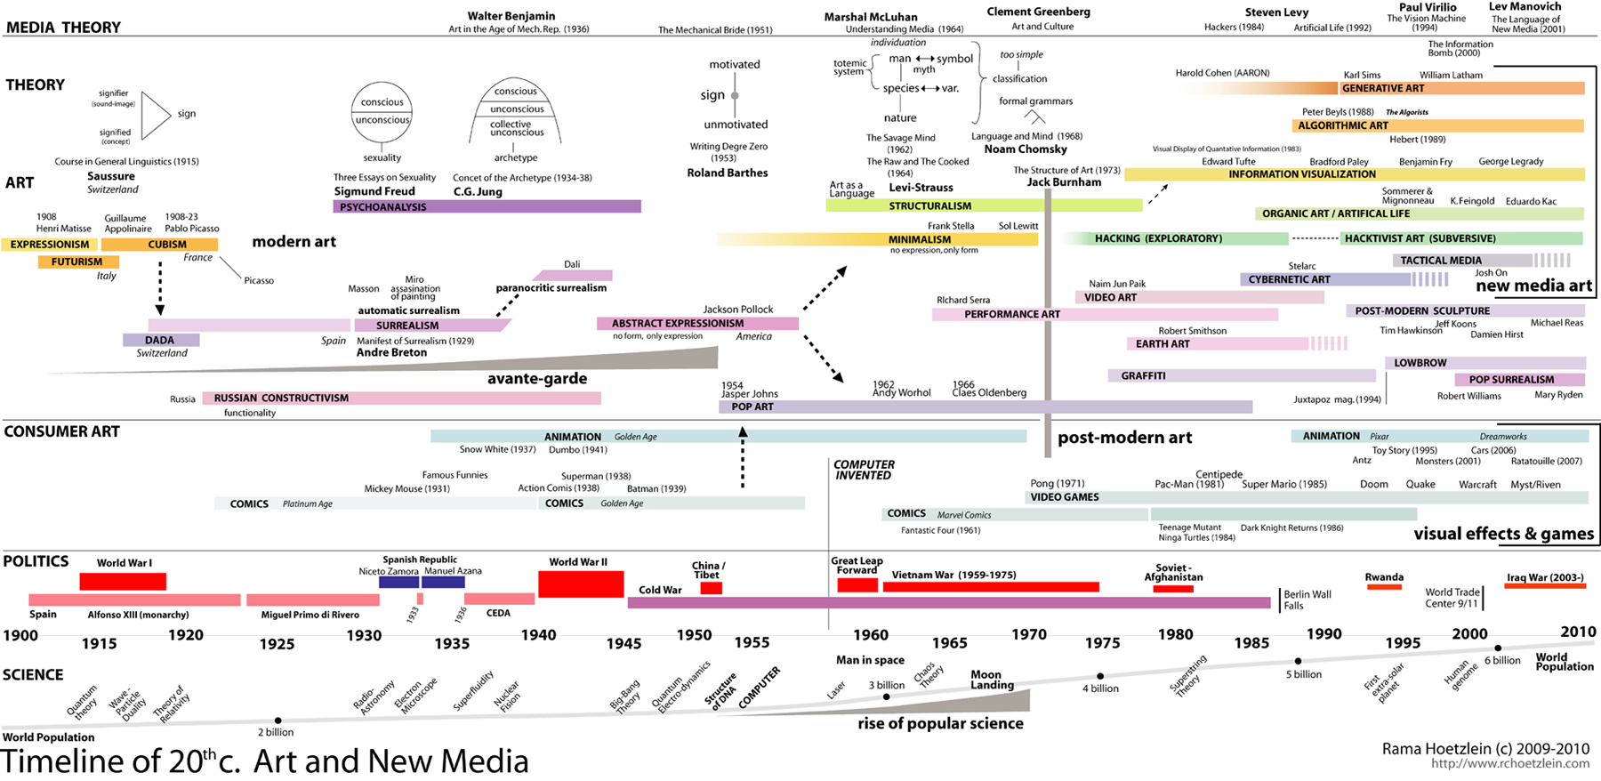

 | America |  |  |  |  | Europe |  |  |  |  |  |  |  | Egypt |  |  |  |  |  | Middle East |  |  |  |  |  |  | (N) India (S) |  |  |  |  |  | Mekong |  |  | China |  |  |  | Japan
-3500 |  |  |  |  |  |  |  |  |  |  |  |  |  |  |  |  |  |  |  | Uruk, writing |  |  |  |  |  |  |  |  |  |  |  |  |  |  |  |  |  |  |  |  |  |  | -3500
-3000 |  |  |  |  |  |  |  |  |  |  |  |  |  | Predynastic |  |  |  |  |  | Sumer |  |  |  |  |  |  |  |  |  |  |  |  |  |  |  |  |  |  |  |  |  |  | -3000
-2500 |  |  | Minoan |  |  |  |  | earl. Helladic |  |  |  |  |  | Old kgdm |  |  |  |  |  | Akkadian |  |  |  |  |  |  | Harappa |  |  |  |  |  |  |  |  |  |  |  |  |  |  |  | -2500
-2000 |  |  |  |  |  |  |  | mid. Helladic |  |  |  |  |  | Mid k. |  | Hyks |  |  |  | old Babyl Assyria |  |  |  |  |  |  |  |  |  |  |  |  |  |  |  | Xia 夏 |  |  |  |  |  |  | -2000
-1800 |  |  |  |  |  |  |  |  |  |  |  |  |  | Hyksos in |  |  |  |  |  |  |  | old Babylonia old Assyria |  |  |  |  | Harappa |  |  |  |  |  |  |  |  | Shang 商 |  |  |  |  |  |  | -1800
-1700 |  |  |  |  |  |  |  |  |  |  |  |  |  |  |  |  |  |  |  |  |  |  |  |  |  |  |  |  |  |  |  |  |  |  |  |  |  |  |  |  |  |  | -1700
-1600 |  |  |  |  |  |  |  |  |  |  |  |  |  |  |  |  |  |  |  |  |  |  |  |  |  |  |  |  |  |  |  |  |  |  |  |  |  |  |  |  |  |  | -1600
-1500 |  |  |  |  | Mycenean |  |  |  |  |  |  |  | Hittite | Hyksos out  Akhenaton  New kgdm |  |  | Mitanni |  |  |  |  | mid Assyria |  |  |  |  | Aryan in |  |  |  |  |  |  |  |  |  |  |  |  |  |  |  | -1500
-1400 |  |  |  |  |  |  |  |  |  |  |  |  |  |  |  |  |  |  |  |  |  |  |  |  |  |  |  |  |  |  |  |  |  |  |  |  |  |  |  |  |  |  | -1400
-1300 |  |  |  |  |  |  |  |  |  |  |  |  |  |  |  |  | Middle Babyl. Assyria |  |  |  |  |  |  |  |  |  |  |  |  |  |  |  |  |  |  |  |  |  |  |  |  |  | -1300
-1200 |  |  |  |  |  |  |  |  |  |  |  |  |  |  |  |  |  |  |  |  |  |  |  |  |  |  |  |  |  |  |  |  |  |  |  |  |  |  |  |  |  |  | -1200
-1100 |  |  |  |  |  |  |  |  |  |  |  |  |  |  |  |  |  |  |  |  |  |  |  |  |  |  | Veda |  |  |  |  |  |  |  |  | Western Zhou 周 |  |  |  |  |  |  | -1100
-1000 | Chavin |  | Villanova |  |  |  |  |  |  |  |  |  |  |  | Hebr, Phoen. |  |  |  |  |  |  |  |  | Assyria dark |  |  |  |  |  |  |  |  |  |  |  |  |  |  |  |  |  |  | -1000
-900 | Olmec |  | Etruscan |  |  |  |  |  |  | Polis |  |  |  |  | Hebrew Phoenic |  |  |  |  |  | New Assyrian empire |  |  |  |  |  | Epic age |  |  |  |  |  |  |  |  |  |  |  |  |  |  |  | -900
-800 |  |  |  |  |  |  |  |  |  | Homer |  |  |  |  |  |  |  |  |  |  |  |  |  |  |  |  |  |  |  |  |  |  |  |  |  | Eastern Zhou |  |  | Spring Autumn |  |  |  | -800
-700 |  |  |  |  |  |  |  |  |  |  |  |  |  |  |  |  |  |  |  |  |  |  |  |  |  |  | Upnishd, Brhmn |  |  |  |  |  |  |  |  |  |  |  |  |  |  |  | -700
-600 |  |  |  |  |  |  |  |  |  |  |  |  |  |  | Media, new Babylon |  |  |  |  |  |  |  |  |  |  |  | Buddha, Mahavir |  |  |  |  |  |  |  |  |  |  |  |  |  |  |  | -600
-500 | Moch. |  | Roman rep |  |  |  |  |  |  | Athens, Socrat. |  |  |  | Achemenid Persian empire |  |  |  |  |  |  |  |  |  |  |  |  | Bimbisara k. |  |  |  |  |  |  |  |  | Eastern Zhou  Laozi, Kouzi |  |  |  |  |  |  | -500
-400 |  |  |  |  |  |  |  |  |  | Alexander |  |  |  |  |  |  |  |  |  |  |  |  |  |  |  |  |  |  |  |  |  |  |  |  |  |  |  |  |  |  |  |  | -400
-300 |  |  | Punic w. |  |  |  |  |  |  | Hellenism |  |  |  | Ptol. Alexandria | Empire of Alexander |  |  |  |  |  |  |  |  |  |  |  | 1st emp: Maurya |  |  |  |  |  |  | Thực |  | War. States, 1st: Qin |  |  |  |  |  |  | -300
-200 | Nazca |  |  |  |  |  |  |  |  | Roman Maced. |  |  |  |  | Antigonid. Seleucid.  Pergamum, Parthia |  |  |  |  |  |  |  |  |  |  |  | Bactria |  |  | Shatavahana kingdom |  |  |  | Triệu |  | Western Han 汉 |  |  |  |  |  |  | -200
-100 |  |  | Gaul w. |  |  |  |  |  |  |  |  |  |  |  |  |  |  |  |  |  |  |  |  |  |  |  | Yueh-chi k. |  |  |  |  |  |  | 1st D. |  |  |  |  |  |  |  |  | -100
0 |  |  | Roman empire |  |  |  |  |  |  | Roman Asia  Jew Diaspora  Constant. christ. |  |  |  |  | Parthia |  |  |  |  |  |  |  |  |  |  |  |  |  |  |  |  |  |  | Hai Bà Trưng,  2nd Dom. |  | Eastern Han |  |  |  | Yayoi  弥生 |  |  | 0
100 |  |  |  |  |  |  |  |  |  |  |  |  |  |  |  |  |  |  |  |  |  |  |  |  |  |  | Kusha- |  |  |  |  |  |  |  |  |  |  |  |  |  |  |  | 100
200 | early |  |  |  |  |  |  |  |  |  |  |  |  |  | Sassanides  Neo Persian  empire |  |  |  |  |  |  |  |  |  |  |  | -ana |  |  |  |  |  |  |  |  | 3 kingdoms |  |  |  | Kofun  古墳kanji in. |  |  | 200
300 | Maya |  |  |  |  |  |  |  |  |  |  |  |  |  |  |  |  |  |  |  |  |  |  |  |  |  | Gupta |  |  |  |  |  |  |  |  | 6 dynst | Juan mongol |  |  |  |  |  | 300
400 |  |  | Rome |  |  |  | Hun |  |  | East Roman |  |  |  |  |  |  |  |  |  |  |  |  |  |  |  |  | Hun | Break up |  |  |  |  |  |  |  | Age Dis -unity |  |  |  |  |  |  | 400
500 |  |  | Merov. |  |  |  |  |  |  |  |  |  |  |  |  |  |  |  |  |  |  |  |  |  |  |  | Harsha emp. |  |  | Pallava |  |  |  | Lý ant. |  |  |  |  |  | Asuka  飛鳥 |  |  | 500
600 |  |  |  |  |  |  | Avar |  |  |  |  | Byzantine emp. |  |  | Omayyad caliphate |  |  |  |  |  |  |  |  |  |  |  |  |  |  |  |  |  | Khm. | 3rd Dom. |  | Tang 唐 |  |  |  |  |  |  | 600
700 |  |  | Carol. |  |  |  | Bulg |  |  | Spain |  |  |  |  | Abbasid caliphate |  |  |  |  |  |  |  |  |  |  |  |  |  |  |  |  |  |  |  |  |  |  |  |  | Nara |  |  | 700
800 |  |  | Viking |  |  |  |  |  |  |  |  |  |  |  | Shiite Persia dominates Caliphate |  |  |  |  |  |  |  |  |  |  |  | Pala k. in Bengal |  |  |  |  |  | Angk |  |  |  |  |  |  | Heian  平安 |  |  | 800
900 | Viking |  | Magy. |  |  |  |  |  |  |  |  |  |  |  |  |  |  |  |  |  |  |  |  |  |  |  |  |  |  | Chola |  |  |  | Ng Đ L |  | North Sung 宋 |  | Khitan 辽 |  |  |  |  | 900
1000 | Maya |  | Capetian |  |  |  |  |  |  |  |  |  |  | Fatim shiite | Turkish intrusions,  Seljuk Sultanate |  |  |  |  |  |  |  |  |  |  |  | Ghazni | Rajput states |  |  |  |  | A.w. | Lý |  |  |  |  |  |  |  |  | 1000
1100 |  |  | Hohenstauf. |  |  |  |  |  |  | reconq |  |  |  |  |  |  |  |  |  |  |  |  |  |  |  |  |  |  |  |  |  |  | Bayn |  |  | South Sung |  | Jin 金 |  |  |  |  | 1100
1200 | Aztec |  |  |  |  | Gengis k |  |  |  | Tartar Russia |  |  |  | Ayub |  |  |  |  |  |  |  |  |  |  | Persian khanate Timur |  | Delhi Sultan |  |  | Pandy |  |  |  | Trần |  |  |  | Yuan |  | Kamakra |  |  | 1200
1300 |  |  | Valois, 100y |  |  |  |  |  |  |  |  | Ottom |  | Mam luke | Ottoman empire |  |  |  |  |  |  |  |  |  |  |  |  |  |  | Vijaya |  |  |  |  |  | 元 (mongol) |  |  |  | Ashikaga |  |  | 1300
1400 |  |  | Habsburg |  |  |  |  |  |  |  |  | Istambl |  |  |  |  |  |  |  |  |  |  |  |  |  |  |  |  |  |  |  |  |  | Lê |  | Ming 明 |  |  |  | Warring countries |  |  | 1400
1500 | Colm |  |  |  |  |  |  |  |  |  |  |  |  |  |  |  |  |  |  |  |  |  |  |  |  |  | Babar conq. Mogul |  |  |  |  |  |  | Lê |  |  |  |  |  |  |  |  | 1500
1600 |  |  | Bourbon |  |  |  |  |  |  | Romanov |  |  |  |  |  |  |  |  |  |  |  |  |  |  |  |  |  |  |  |  |  |  |  | Ng | Lê | Qing 清(mandchu) |  |  |  | Osaka b.  Edo |  |  | 1600
1700 |  |  |  |  |  |  |  |  |  |  |  |  |  |  |  |  |  |  |  |  |  |  |  |  |  |  |  |  |  |  |  |  |  |  |  |  |  |  |  |  |  |  | 1700
1780 | Indepdc |  |  |  |  |  |  |  |  |  |  |  |  |  | Afghan incurs. |  |  |  |  |  |  |  |  |  |  | Afghan |  |  |  |  |  |  |  |  |  | Tibet protector. |  |  |  | Edo  江戸 Tokugaw徳川 |  |  | 1780
1790 |  |  |  | Fr revolution |  |  |  |  |  |  |  |  |  |  |  |  |  |  |  |  |  |  |  |  |  |  |  |  |  |  |  |  |  |  |  |  |  |  |  |  |  |  | 1790
1800 |  |  |  |  |  |  |  |  |  |  |  |  |  |  |  |  |  |  |  |  |  |  |  |  |  |  |  |  |  |  |  |  |  | Nguyễn |  |  |  |  |  |  |  |  | 1800
1810 |  |  |  | Napoleon |  |  |  |  |  |  | Napoleon |  |  |  |  |  |  |  |  |  |  |  |  |  |  |  |  |  |  |  |  |  |  |  |  |  |  |  |  |  |  |  | 1810
1820 |  |  |  |  |  | Elec |  |  |  |  |  |  |  |  |  |  |  |  |  |  |  |  |  |  |  |  |  |  |  |  |  |  |  |  |  |  |  |  |  |  |  |  | 1820
1830 |  |  |  |  |  |  |  |  |  |  |  |  |  |  |  |  |  |  |  |  |  |  |  |  |  |  |  |  |  |  |  |  |  |  |  | Opium w. |  |  |  |  |  |  | 1830
1840 | Mexc w |  |  |  |  |  |  |  |  |  |  |  |  |  |  |  |  |  |  |  |  |  |  |  |  |  |  |  |  |  |  |  |  |  |  | Taiping revolt |  |  |  | Tempo r. |  |  | 1840
1850 |  |  |  |  |  |  |  |  |  |  | Crimean w. |  |  |  |  |  |  |  |  |  |  |  |  |  |  |  |  |  |  |  |  |  |  |  |  |  |  |  |  | open |  |  | 1850
1860 | Civil w. |  |  |  |  | Fr-De w. |  |  |  |  |  |  |  |  |  |  |  |  |  |  |  |  |  |  |  |  |  |  |  |  |  |  |  |  |  |  |  |  |  | Yoshnb |  |  | 1860
1870 |  |  |  |  |  |  |  |  |  |  | Turk w |  |  |  |  |  |  |  |  |  |  |  |  |  |  |  |  |  |  |  |  |  |  |  |  |  |  |  |  | Meiji  明治 |  |  | 1870
1880 |  |  |  |  |  | ICE |  |  |  |  |  |  |  | Suez |  |  |  |  |  |  |  |  |  |  |  |  | Maratha w. |  |  |  |  |  |  | Fr colon |  |  |  |  |  |  |  |  | 1880
1890 |  |  |  |  |  |  |  |  |  |  |  |  |  | Englsh |  |  |  |  |  |  |  |  |  |  |  |  |  |  |  |  |  |  |  |  |  |  |  |  |  |  |  |  | 1890
1900 |  |  |  |  |  |  |  |  |  |  |  |  |  |  |  |  |  |  |  |  |  |  |  |  |  |  |  |  |  |  |  |  |  |  |  | Boxer revolt |  |  |  | Russia w |  |  | 1900
1910 | WWI |  |  |  |  |  |  |  |  |  | WWI |  |  |  |  |  |  |  |  |  |  |  |  |  |  |  | Hindu reform |  |  |  |  |  |  |  |  | Republic |  |  |  | Taisho |  |  | 1910
1920 |  |  |  |  |  | Muss |  |  |  |  | USSR |  |  |  | Turkey |  |  |  | Iraq |  |  |  |  |  |  | Iran | British rule |  |  |  |  |  |  |  |  |  |  |  |  | Showa  昭和 |  |  | 1920
1930 | Depres |  |  |  |  |  |  |  | 3rd Reich |  |  |  |  |  |  |  |  |  |  |  |  |  |  |  |  |  |  |  |  |  |  |  |  |  |  | Japan w. |  |  |  |  |  |  | 1930
1940 | WWII |  |  | Franco |  |  |  |  |  |  | WWII |  |  | Egypt |  |  |  |  |  |  |  |  |  |  |  |  |  |  |  |  |  |  |  |  |  |  |  |  |  |  |  |  | 1940
1950 | Kor w |  |  |  |  |  |  |  |  |  |  |  |  |  |  |  |  |  | Israel |  |  |  |  |  |  |  | Pakistan |  | India |  |  |  |  |  |  | Korea w. |  |  |  |  |  |  | 1950
1960 | VN w |  |  |  |  |  |  |  |  |  |  |  |  |  |  |  |  |  |  |  |  |  |  |  |  |  |  |  |  |  |  |  |  | VN w. |  |  |  |  |  |  |  |  | 1960
1970 |  |  |  |  |  |  |  |  |  |  |  |  |  |  |  |  |  |  |  |  |  |  |  |  |  |  |  |  |  |  |  | Bangladesh |  |  |  | Cultural revol. |  |  |  |  |  |  | 1970
1980 |  |  |  |  |  |  |  |  |  |  | Afghan w. |  |  |  |  |  |  |  |  |  |  |  |  |  |  | Isl. Rep |  |  |  |  |  |  |  |  |  |  |  |  |  |  |  |  | 1980
1990 | Gulf w |  |  |  |  |  |  |  |  |  |  |  |  |  |  |  |  |  |  |  |  |  |  |  |  |  |  |  |  |  |  |  |  |  |  |  |  |  |  | Heisei  平成 |  |  | 1990
2000 | Iraq w |  |  |  |  |  |  |  |  |  |  |  |  |  |  |  |  |  |  |  |  |  |  |  |  |  |  |  |  |  |  |  |  |  |  |  |  |  |  |  |  |  | 2000
2010 |  |  |  |  |  |  |  |  |  |  |  |  |  | Spring |  |  |  |  |  |  |  |  |  |  |  |  |  |  |  |  |  |  |  |  |  |  |  |  |  |  |  |  | 2010

Comments

The “world stage”: The civilizations have been aligned on a single-dimension axis following their affinities and main interactions. With this setup, the Mongol-Hunnish-Manchu populations seem to spring out from “behind the stage” in an apparently disconnected but yet synchronized manner.
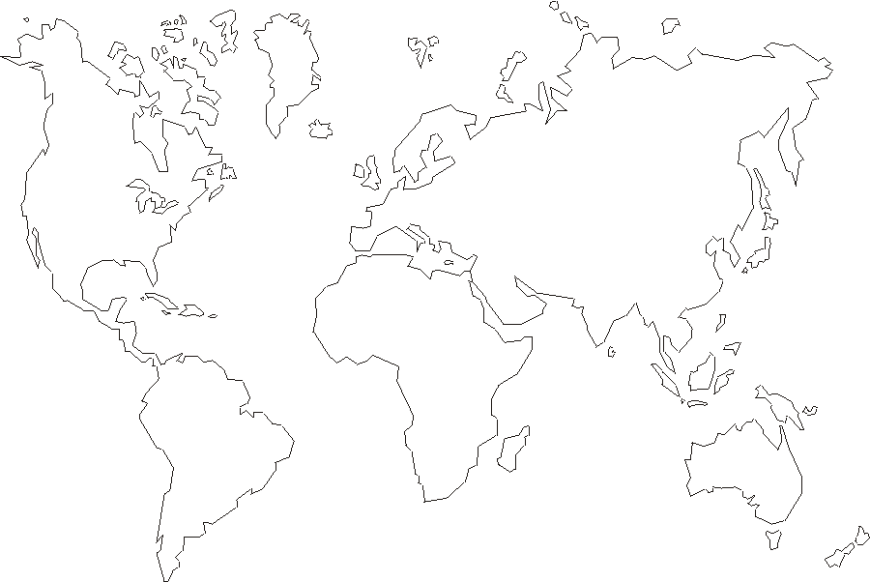

The color classification is proposed generally based on linguistic criteria. The following list gives some hybrid cultures:
 | Language | Script | Architecture | Religion
Japanese | Altaic + Austronesian | Chinese | Chinese | Buddhism-Mahayana |  | Shinto,
Persian | IE-farsi | Cuneiform | Babylonian | Zoroastrism
Ottoman | Altaic | Sinaic:Okhron? |  | Islam
Hunnish | Altaic | ? |  | ?
Mongol | Altaic | Sinaic -mongol |  | Buddhism- Vijrayana
Indian (north) | IE-sanskrit | Sinaic -devanagari |  | Vedic | Buddhism- Mahayana
Indian (south) | Dravidian | Sinaic -pali | South Indian | Vedic | Buddhism-Theravada
Khmer | Mon-khmer | Sinaic -pali | South Indian | Buddhism-Theravada
Vietnam | khmer+Chinese | Chinese | Chinese | Buddhism-Mahayana, Tao

Maps and timelines mostly taken from http://www.hyperhistory.com/online_n2/History_n2/a.html

