太极拳Thái Cực Quyền

Youtube videos

- Basic 1 https://youtu.be/sM6lWUvc62Q
- Basic 3 https://y outu.be/mPnvcUuJqqs
- Basic 4 https://youtu.be/zpkT3RlgVqo
- Exercises with balls: https://www.youtube.com/watch?v=jTh-W1_gCHo
- Form 1 https://www.youtube.com/watch?v=VIH2Q56qLNA
- Form 3 back https://www.youtube.com/watch?v=WRoX_MZ491g
- Form 3 front https://www.youtube.com/watch?v=4p3M0K6rjXo
- Form 8 https://www.youtube.com/watch?v=6jOaRyhtkUs
- Form 9 https://www.youtube.com/watch?v=f9k_u5T1-Qk

Original location of this document: www.notesdevoyage.com/ftp/Texte/Taichi.docx

Form 1 – 24 postures (Peking form)
https://en.wikipedia.org/wiki/24-form_tai_chi_chuan
http://www.khicongduongsinh.com/luyen-tap-thai-cuc-quyen-24-thuc.html

Title convention: “English name [Chinese] Chinese phonetics – formal Vietnamese (ordinary Vietnamese)”
Abbreviations: RH right hand, LH: left hand, 2H: two hands, RF: right foot, LF: left foot, RA: right arm, LA: left arm, CW: clockwise, CCW: counter-clockwise.

- Opening 起势Qǐshì - Khởi thức (bắt đầu)
  - Step on left side
  - Both arms frontwards
  - Flex legs and grasp arms down
  - LH turns CCW
  - RH follows holding the ball
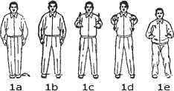

- Horse hair split 野马分鬃Yémǎ Fēnzōng - Dã mã phân tung (ngựa rừng hất bờm)
  - Horse LH
  - Horse RH
  - Horse LH
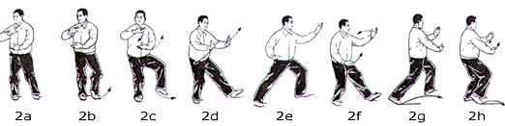
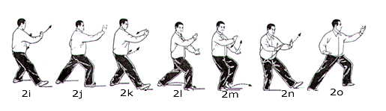

- The white crane opens its wings, 白鹤亮翅Báihè Lìangchì - Bạch hạc lượng xí (hạc trắng xòe cánh)
  - RF step fwd behind
  - Hands open like wings
  - Parry RH
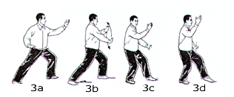

- Crossed hand-foot 搂膝拗步Lōuxī Àobù - Lâu tất ảo bộ (tay vuốt gối, chân linh hoạt)
  - Crossed RH LF
    - Parry LH, LH under right shoulder
    - LF forwards, RH push, LH brushes left knee, pushes down
  - Crossed LH RF
  - Crossed RH LF
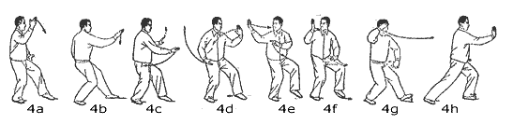
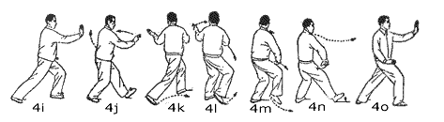
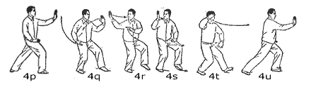

- Play pipa 手挥琵琶Shǒuhūi Pípā - Thủ huy tỳ bà (tay gảy đàn tỳ bà)
  - RF fwd behind
  - Hands open like wings
  - Hold guitar LF straight fwd
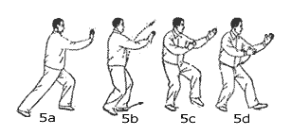
- Monkey retreats 倒卷肱Dào juǎn gōng - đảo niệm hầu (khỉ khoa tay múa chân)
  - Monkey RH
    - RH circle crawl, LF step back bent
    - RH RF straight
  - Monkey LH
  - Monkey RH
  - Monkey LH
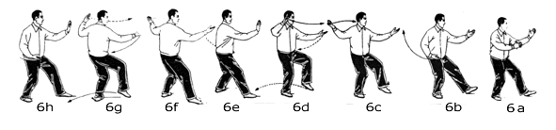
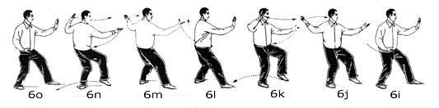
- Catch bird tail left左揽雀尾Lǎn què wěi - lãm tước vĩ (nắm đuôi chim bên trái)
  - Bird left
    - RH circle up, Hold egg RH up, LF back together
    - Horse stroke LH, 掤Peng - bằng (ngăn đỡ)
    - RH swipes: 捋Lǚ - lý (kéo)
    - LH stroke down, RH follows face up, legs bend back
    - Push crossed hands RH in, leg bend fwd: 擠Jǐ - tê (ép)
    - Open hands, hands back low, body back
    - Hands push until knees: 按Àn - án (đẩy)
  - Transition
    - Rh lead like a banner to the right, feet spin
    - RF step back together,
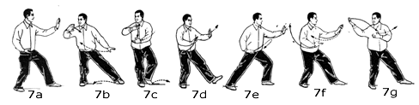
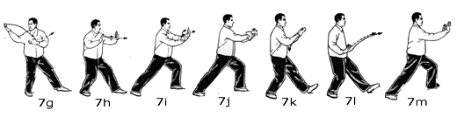

- Catch bird tail right 右揽雀尾 - lãm tước vĩ
  - Bird right
  - Transition
    - LH starts cloud hands left, foot don’t move
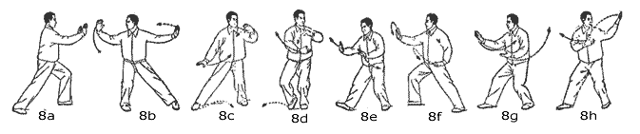
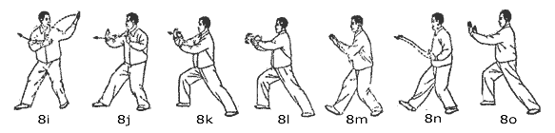

- Simple whip单鞭Dān biān - Đơn tiên (cây roi)
  - LH CW, stops at right elbow
  - RH CCW, stops up
  - RH fall like a withered bud
  - LF and LH forwards
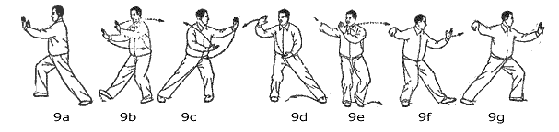
- Cloud hands 云手Yúnshǒu - Vân thủ (cuộn tay như mây)
  - LH CW
  - RH CCW and RF joins other
  - LH counter and LF aside
  - RH clockwise and RF joins
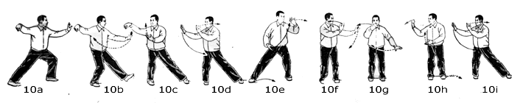

- Simple whip单鞭Dān biān - Đơn tiên
  - LF CCW until below right elbow
  - RH withers
  - LF and LH fore
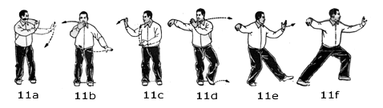
- Stroke on the horse neck高探马Gāo tàn mǎ - Cao thám mã (vuốt bờm ngựa)
  - LF step fore behind
  - RH pushes fore, body moves back
  - LH below RE
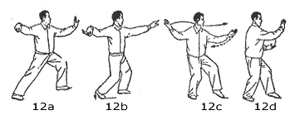
- Kick right右蹬脚dēng jiǎo - Hữu đăng cước (đá gót chân phải)
  - RH clock down till face
  - LH clock up till face
  - RK up
  - RF kick, RH LH extend
  - LF down in front
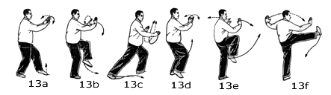

- Double hit ears双峰贯耳Shuāng fēng guàn ěr - Song phong quán nhỉ (hai u nắm tay xuyên mang tai)
  - Move back, 2H back to waist
  - 2H open low
  - Fists hit crush, body forwards
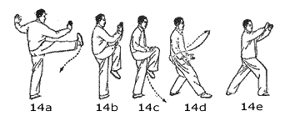

- Kick left转身左蹬脚Zhuǎnshēn zuǒ dēngjiǎo - Chuyển thân tả đăng cước
  - LH CCW down
  - RH CCW up till face
  - LE up
  - Kick and 2H extend
  - LF down
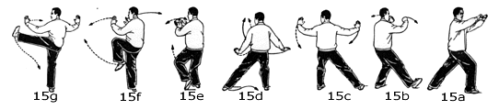

- Grab snake tail left, Golden rooster左下势 独立- Tả hạ thế độc lập (ngồi xuống thấp bên trái)
  - Grab snake tail left
    - RH fist up
    - LF extend low
    - LH swim low, RH still behind
  - Golden rooster right
    - Arise from swim on LF
    - Lift right knee with right arm in L shape in front
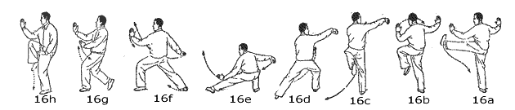

- Grab snake tail right, Golden rooster右下势独立- Hữu hạ thế độc lập
  - Grab snake tail left
    - LH fist up
    - RF extend low
    - RH swim low, LH still behind
  - Golden rooster left
    - Arise from swim on RF
    - Lift left knee with left arm in L shape in front
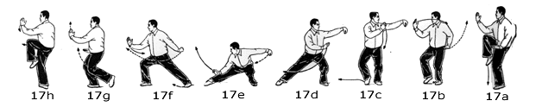

- Jade Maiden weaves left,左玉女穿梭yùnǚ chuānsuō - ngọc nữ xuyên thoa (cô gái đẹp đưa thoi)
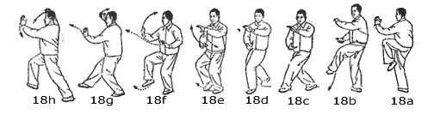

- Jade Maiden weaves right, 右玉女穿梭 yùnǚ chuānsuō - ngọc nữ xuyên thoa (cô gái đẹp đưa thoi)
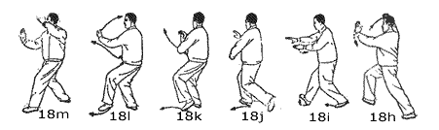

- Needle at the sea bottom海底针Hǎidǐ zhēn - Hải để châm (kim chìm đáy biển)
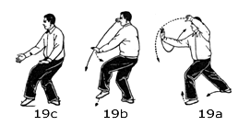

- Fan 闪通臂Shǎn tōng bì - Thiểm thông tý (cánh tay như tia chớp)
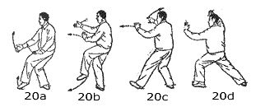

  - Turn, deflect, parry, punch, 转身搬拦捶Zhuǎnshēn Bānlánchuí
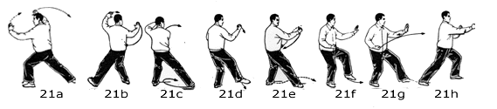

- As if closing door如封似闭Rúfēng shìbì - Như phong tự bế (ngăn, chận, đóng lại)
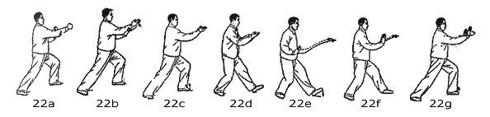

- Cross hands十字手Shízìshǒu - Thập tự thủ (tréo tay chữ thập)
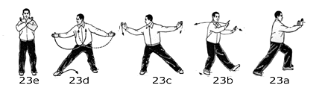<=

- Closing收势Shōushì (Thu thế)
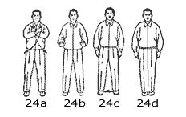

Form 3

- Opening
- Horse, bird, whip
  - RH up but RL right
  - Horse left front
  - Bird right (joining only hands’ palm)
  - Shift hands left as if holding a ball
  - Single whip RH up, extend L
  - Horse R
- Crane, 2 cross push, fist down, 2 horses
  - Crane
    - RH in L-shape, LH in elbow,
    - turn right,
    - lh fall on ll,
    - flap wings ra la
  - Cross push right hand
  - Cross push left hand
  - Fist down
    - Lh wave CW .
    - Lf joins rf.
    - Rh at waist in fist.
    - Lf stretches left.
    - Lh swip parry. Rh hit down opponent leg.
  - Horse R & L
- Water snake, monkey, needle, fan, cloud, 2 maiden
  - “Snake over water”
    - Turn right
    - Fist brace RH
    - LH pushes front
    - LH turns CCW
    - Fist Pipa: LF front and LH like pipa, but RH in fist below
    - Turn to left with LH high
    - Fist pipa
  - Monkey retreat
    - LH CCW
    - RH CCW, stop a waist
  - Needle LF
    - LH CW, to R elbow
    - RH up at shoulder level like cross push
    - LH down till L knee
    - RH pick needle
  - Fan left
    - Fan left
    - Transfer right
    - Transfer left again
  - Cloud hand R
  - Maiden R & L
- 3 Kicks
  - kick R , hit ears
    - from maiden, move back, RH up
    - arms turn horizontally to the L
    - LH up RH down
    - RH up with R knee, kick
    - Hit ears
    - Move back for transition
  - kick L
  - Kick hand R hitting RH
    - Spin R crossing legs, 2H crossed on belly
    - 2H up crossed over head
    - RH hit RF
- 2 Snake brace, whip, snake fist
  - Snake tail bracing 2H (see basic 3) L R
  - Wave horizontally to the L (see step 2 of beginning)
  - Whip L
  - Snake, crossed fists
    - Snake L very low, without moving feet
    - RF moves front, weight on LF
    - RH meets LH in fist
- Brace and hit hands
  - 2H fall CCW, RF step back
  - LH CW down, RH up protecting
  - Half turn R, raise LH , lower RH (hold wood log)
  - Step LF, half turn R
  - LA CW, RA CW, 2 arms crossed, RA up LH below,
  - hit RH with RF
  - Snake tail fists brace 2H R
- Fist and close door (see end of set 1)
  - Turn, deflect, parry, Punch R 转身搬拦捶
  - As if closing door 如封似闭
  - Cross hands十字手
- Closing收势

Form 5

I - To the left
- Opening
- Horse, crane, cross, whip
  - Horse right, direct likage
    - Swing left
    - Horse right
  - Crane left
    - From horse, turn left directly without leg move
    - crane
  - Cross-push RH, direct likage
  - Whip from horse
    - From CP, turn right
    - Horse right start, with LH on right elbow
    - RH turns wide, coming back to cheeks for whip
    - Whip left
- Pipa, Short birds, Fists, Bird
  - Pipa
    - RA turns forth while LA back, RF joins LF
    - LA down and forth, invert foot weight
    - Left heel forth, hold pipa
  - 3 Short birds
    - Short bird right
      - Sweep RH CW, RF joins LF
      - 2H stoke down like bird tail
      - RF step forth, 2H push like bird tail
    - Short bird left
    - Short bird right
  - Fist left
    - LA waves to the right
    - LH in fist forth, LF forth like start of water snake
  - Fist left like a door
    - LH in fist turns up and back, RF joins LF
    - RF steps forth, LH fist hit with RH holding below
  - Bird tail left
    - LF joins RF, 2H fall like bird tail
    - Bird tail, like form 1 : hands broadly held
II - To the right
- Brandish sword
  - Turn right, RA CW
  - Stand on LF, 2H in shape of skull and bones: “Nguy hiem chet nguoi”
  - RF step right, RH brandish sword, 2H up bracing
- Water snake turns
  - RH forth, LH back, LF joins RF
  - LF heel forth, LH forth, RH below elbow in fist
  - LH high left, body turns left, RH low
  - RH forth up, LH low back, RF joins LF
  - Invert feet weight
  - LF heel forth, LH down forth, RH below elbow in fist
- 4 monkey retreats
- 4 cross push in 4 directions
- Bird and fist right
  - Keep RH up, LH on right elbow, LF back stretching legs
  - 2H fall down back, join like bird tail and push back
  - RH turns CCW, body moves back
  - LH turns CCW, rises, hit down in fist on right
III - To the left again
- 3 Reversed monkeys
  - RH rises CCW, body turns left 180
  - RH stretches, while RF
- Kick brace, brace kick
  - LF kicks RH
  - LF step left, RF step left, LF left, 2H brace
  - 2H move right, LH left up, kicked by LF
  - LF step forward, RF too, 2H brace
- Fist and snake
  - Turn hands and brace LH fist
  - Body turns left, LH fist up, RH fist horizontal
  - Snake move to the right
IV - To the right again
- Push ceiling 2
  - Forward, move up left knee with LH
  - Then up right knee and RH
- Whip right
  - RF back, LH up left with RH below elbow
  - 2H fall to the right, join together like bird tail
  - 2H start to press left, but then LH turns horizontally in circle CCW
  - Simple whip right
- 2 horse
  - Horse right
  - Horse left
- Stroke horse, 2 kicks

- Fist kicks the earth
  - Stand straight with RH fist in LF
  - LF back left, 2H on right knee
  - RH up turns CCW to hit down
- Needle and fan

Basic 1 – 8 postures

- Opening 起势
- 2 Monkey, hands only, L R
- 2 Crossed hand-foot 搂膝拗步 push L R
- 2 Horses野马分鬃 L R
- 2 Clouds云手L R
- 2 roosters独立 R L
- 2 kicks蹬脚 LF RF
- 2 snake下势 L R
- 2 maiden玉女穿梭 L R
- Closing收势

Basic 2 – Bird tail

- Opening起势
- Bird tail 揽雀尾
- Closing

Basic 3 – Elbow swivels

- Opening
- 2 pushes
  - Simple push L & R
  - Push and step forward, L & R
    - Push hands,
    - Step forward
    - Turn hand in jade maiden
- Fist R & L
  - Swivel LA,
  - caress bird tail back
  - turn 2 arms side by side
  - brace left fist out, right hand aside
- 3 snakish
  - Snake tail and fist brace L & R
    - Start high like snake tail
    - Extend LL while both hands fall
    - Turn around waist to the left
    - Brace both fist
  - Snake tail and golden rooster L R (classic)
  - Snake tail and rooster with hand lifting sky L & R
- 2 waist swans
  - Turn and fencing serving, hand and knee risen together L & R
    - Extend LL, RH to the R with LH below
    - Move 2H to the L, then fall to waist
    - Lift LH with LK, RH parries on the R
    - LL down, move body left as if fencing, RL stretched
    - Same on the left
  - Cross hands and hold lamp lifting leg L & R
    - Cross 2h in front
    - Fall to waist L
    - Lift RH with LK, RH pushes L, LH holds a lamp
- Cloud hands + whip R, L
  - Cloud R
  - Whip L
  - Cloud L
  - Whip R
- Ending

Basic 4 – Strong

- Opening
- 3 punches
  - Punch down L R
    - Rise arms like cross push
    - High arm punches down
  - Throw the net R L
    - Hold ball like horse
    - Throw to opposite side
    - Step forward and push gently
  - Throw punchy net R L
- 3 Kicks
  - One-foot kick, hitting one hand, R L
  - One-foot kick quick (hit aside, classic), R L
  - One-foot Kick both hands R L
- Cloud hands quick, R L
- Closing

