繁體字 | 說文解字 | 六書通 | 金文 | 甲骨文 | Explanations
如 | 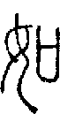 | 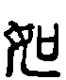 |  | 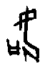 | 從隨也從女從口徐锴曰女子從父之教從夫之命故從口會意  From mouth 口 (character created for sound) and phonetic (woman) 女. Meaning "if".
來 | 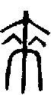 | 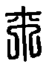 | 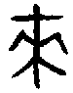 | 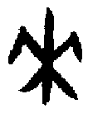 | 周所受瑞麥來麰一來二縫象芒朿之形天所來也故為形來之來詩曰詒我來麰凡來之屬皆從來  Primitive pictograph 來. Fruit hanging on a tree. Meaning coming.
去 | 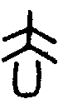 |  | 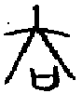 | 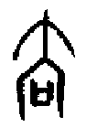 | 人相違也從大凵聲凡去之屬皆從去Compound pictograph 去. From man 土大 leaving an enclosure 𠙴. Meaning to go.
事 | 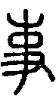 | 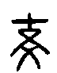 | 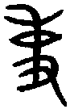 |  | 職也從史之省聲  A hand 又 writing down what is said 口. Meaning business, which is written down. See 史吏
史 | 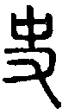 | 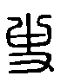 | 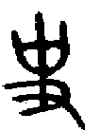 | 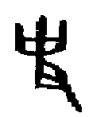 | 記事者也從又持中中正也凡史之屬皆從史  A hand 又 which writes with a brush what is said 口. Meaning history. See 吏事
母 | 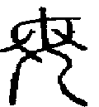 |  |  |  | A womans brests with nipples. Meaning mother.
曾 | 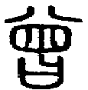 | 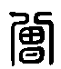 |  |  | 詞之舒也從八從曰**聲  From to speak 曰 and Augmentation stroke (meaning to release) 八 and phonetic (window) 𡆧. Meaning the past.
會 | 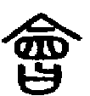 | 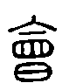 |  | 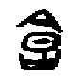 | 合也從亼從曾省曾益也凡會之屬皆從會  From mouth above 亼 and remnant to talk 曾. Meaning meeting.
合 |  |  |  |  | 合口也從亼從口  From inverted mouth 亼 and mouth 口, two people talking. Meaning united.
我 | 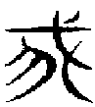 | 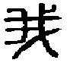 | 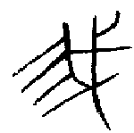 |  | The character for "I" was originally a rake 耙, borrowed for its pronunciation.  施身自謂也或說我頃頓也從戈從****或說古垂字一曰古殺字凡我之屬皆從我
義 | 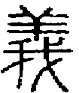 | 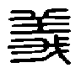 | 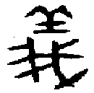 | 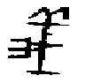 | From my 我 and goat 羊. The generocity of giving a goat as a sacrifice each year to the poor. Meaning generocity.  已之威儀也從我羊臣鉉等曰與善同意故從羊
善 | 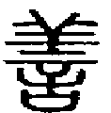 | 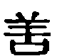 | 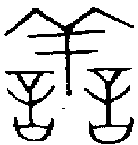 |  | From say a lot 誩 and goat 羊 (offering). Meaning virtuous.  吉也從誩從羊此與義美同意
美 | 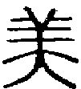 | 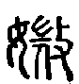 | 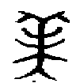 | 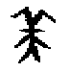 | Compound pictograph 美. From a man 大 with a sheep skin hat 羊. Meaning beautiful.  甘也從羊從大羊在六畜主給膳也美與善同意

Source: http://www.chineseetymology.org

